BC Regional Grass Track Championship Youth Omnium Prompt Start at 7 pm
Regional Champs Event Programme – SIGN ON OPENS AT 6.15 AND CLOSES AT 6.50
7pm PROMPT Start for the U8/U10/U12 - Start List
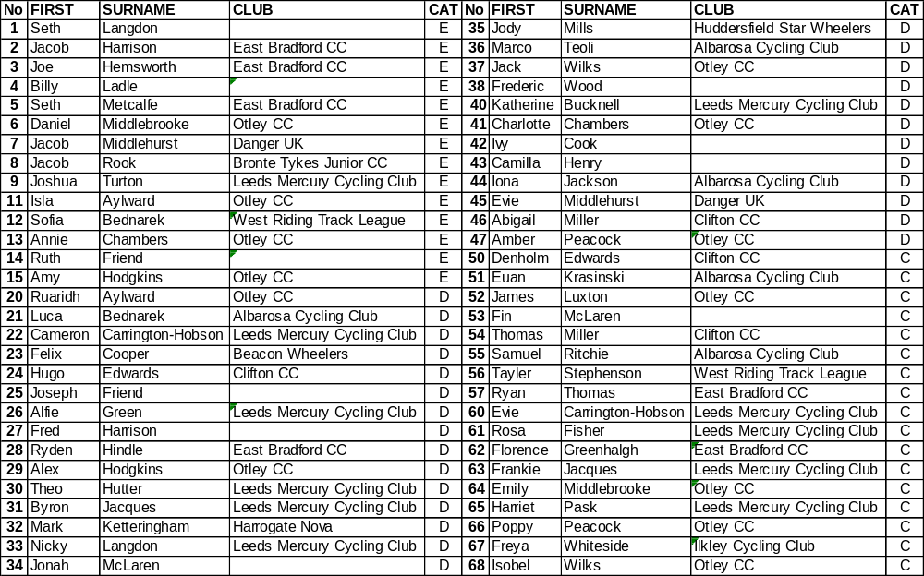

The Omnium consists of three parts, as below:

Under 8 Events – 1 Lap Sprint + 1/2 Lap Time Trial + 1 Lap Scratch Race
Under 10 Events 1 Lap Sprint + 1 Lap Pursuit + 2 Lap Scratch Race
Under 12 Events 1 Lap Sprint + 2 Lap Pursuit + 3 Lap Scratch Race
FOR THE SPRINT - ONLY THE FINALS CARRY POINTS FOR THE OMNIUM, everyone else will be given the same points as 7th place
Omnium Event A
Event 1 - U8 Boys 1 Lap Sprint Heats
U8 Boys  3 to Final  per Heat | Heat 1 | 1 | 3 | 5 | 7 | 9
U8 Boys  3 to Final  per Heat | Result
U8 Boys  3 to Final  per Heat | Heat 2 | 2 | 4 | 6 | 8
 | Result
Event 2- U8 Girls 1 Lap Sprint Final
U8 Girls  Final |  | 11 | 12 | 13 | 14 | 15
U8 Girls  Final | Result

Event 3 - U10 Boys 1 Lap Sprint Heats
U10 Boys  2 to final  per Heat | Heat 1 | 20 | 23 | 26 | 29 | 32 | 35 | 38
U10 Boys  2 to final  per Heat | Result
U10 Boys  2 to final  per Heat | Heat 2 | 21 | 24 | 27 | 30 | 33 | 36
U10 Boys  2 to final  per Heat | Result
U10 Boys  2 to final  per Heat | Heat 3 | 22 | 25 | 28 | 31 | 34 | 37
 | Result

Event 4 - U10 Girls 1 Lap Sprint Heats –
U10 Girls  3 to Final  per Heat | Heat 1 | 40 | 42 | 44 | 46
U10 Girls  3 to Final  per Heat | Heat 2 | 41 | 43 | 45 | 47

Event 5 U12 Boys 1 Lap Sprint Heats –
U12 Boys  3 to Final  per Heat | Heat 1 | 50 | 52 | 54 | 56
U12 Boys  3 to Final  per Heat | Heat 2 | 51 | 53 | 55 | 57

Event 6 U12 Girls 1 Lap Sprint Heats
U12 Girls  3 to Final  per Heat | Heat 1 | 60 | 62 | 64 | 66 | 68
U12 Girls  3 to Final  per Heat | Heat 2 | 61 | 63 | 65 | 67

Event 7 Under 8 Boys 1 Lap Sprint Final
U8 Boys Sprint Final

Event 8 Under 10 Boys 1 Lap Sprint Final
Boys
Sprint Final

Event 9 Under 10 Girls 1 Lap Sprint Final
Girls
Sprint Final

Event 10 Under 12 Boys 1 Lap Sprint Final
Boys
Sprint Final

Event 11 Under 12 Girls 1 Lap Sprint Final
Girls
Sprint Final

Omnium Event B
Event 12 Under 8 ½ Lap Time Trial Line up in number order 1-9 and 11-15 Boys then Girls
Event 13 4 Station Pursuit For U10/U12 Riders
Riders in each heat race against each other for the no of laps stated.
HEAT | NO OF LAPS | AGE CAT | STATION 1 | STATION 2 | STATION 3 | STATION 4
1 | 1 | U10B | 20 | 21 | 22 | 23
2 | 1 | U10B | 24 | 25 | 26 | 27
3 | 1 | U10B | 28 | 29 | 30 | 31
4 | 1 | U10B | 32 | 33 | 34 | 35
5 | 1 | U10B | 36 | 37 |  | 38
6 | 1 | U10G | 40 | 41 | 42 | 43
7 | 1 | U10G | 44 | 45 | 46 | 47
8 | 2 | U12B | 50 | 51 | 52 | 53
9 | 2 | U12B | 54 | 55 | 56 | 57
10 | 2 | U12G | 60 | 61 | 62 | 63
11 | 2 | U12G | 64 |  | 65
12 | 2 | U12G | 66 | 67 | 68

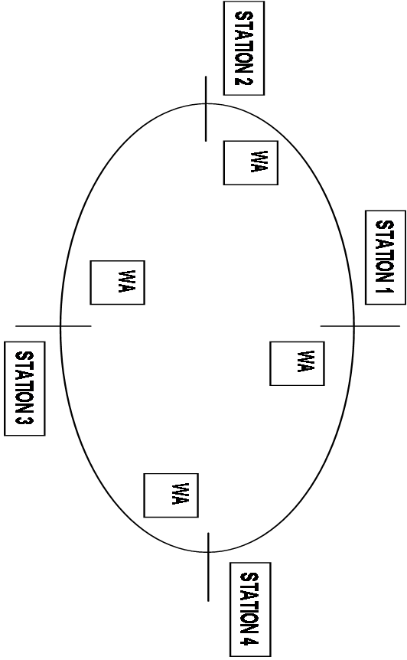
Scratch
PAVILLION

Omnium Event C
Event 14 Under 8 Boys 1 Lap Scratch Race Rolling Start No’s 1-9
Event 15 Under 8 Girls 1 Lap Scratch Race Rolling Start No’s 11-15
Event 16 Under 10 Boys 2 Lap Scratch Race Rolling Start No’s 20-38
Event 17 Under 10 Girls 2 Lap Scratch Race Rolling Start No’s 40-47
Event 18 Under 12 Boys 3 Lap Scratch race Rolling Start No’s 50-57
Event 19 Under 12 Girls 3 Lap Scratch Race Rolling Start No’s 60-68
Fun races as Time Allows while results are finalized.
Youth Prize Presentation
Further Information:The Championship is under the BC Technical Regulations. No Entry On Line for the Championship Events. Warming up from 6.15pm once the track is set up..
3) Officials to use the Lakeside Car Park.
4) Competitors cars will not be allowed at the trackside.
5) Toilets and changing facilities are available in the cricket pavilion by the track.
6) Tea/Coffee/Cold drinks etc are available in the pavilion.
7) U8,U10,U12 riders must use freewheel bikes in good working order.
8) U14,U16 must use track bikes with lock rings and no brakes.
9) Riders must hold a valid BC racing licence, not just membership or Ride membership or no ride.
10) Proposed points for Youth Omnium:1 for 1st then ,2,3,4,5,6 etc. Points only given for the sprint finals, the pursuit and top 6 in the scratch. All other placings in the heats will be given points equal to the next place after the final. In case of a tie for the Youth event we will go back to the Scratch results. if still tied, back to pursuit time/Time trial Time.
It is likely this event will take a while to complete for the young riders due to the numbers entered, so please be patient and we may run later for your usual races as a result.
For the Pursuit Event -Please ensure all youth riders are in their waiting areas (WA) when this event is announced. The organizer reserves the right to make changes on the night as these are only guidelines.
The Judge’s decision is final.

