PROGRAMME SUBJECT TO CHANGE DEPENDING ON NUMBERS AND ABILITIES
THESE ARE PROVISIONAL GROUPS AND HANDICAPS
FREEWHEEL GROUPS:
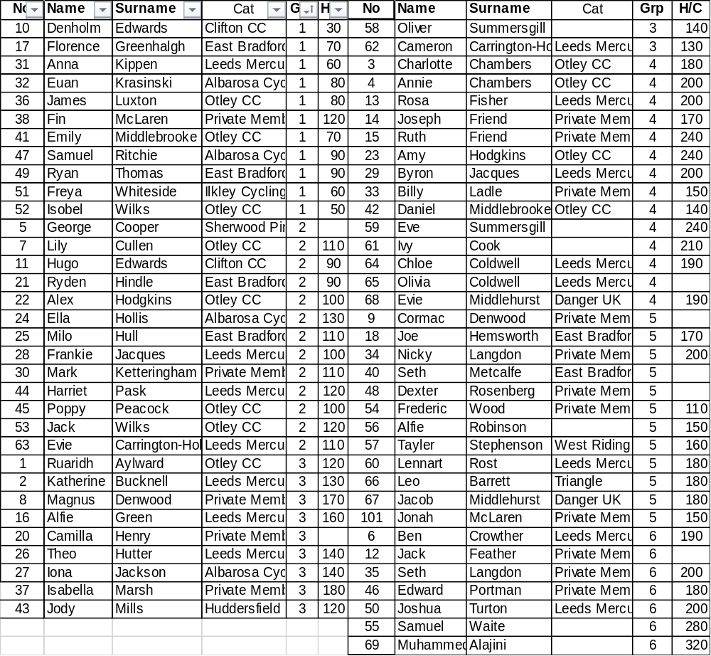
FIXED WHEEL GROUPS:
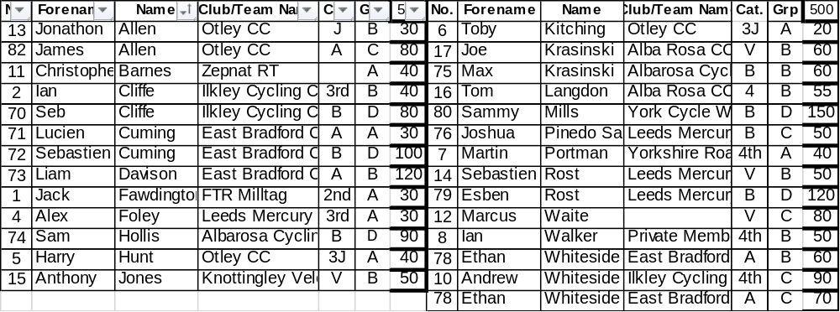

6.45 pm Start Prompt for U8/U10/U12
Race 1 1/2 Lap TT ALL NEW RIDERS WHO HAVEN’T HAD A TIME TRIAL YET
½ Lap Time Trial (Line up at the ½ way line in number order opposite side to the pavilion in number order, lowest first.)
You will ride half a lap to cross the finish line after the judges near the pavilion
Freewheel Scratch Races:
Race 2: Group 5 & 6 Boys 1 Lap Sprint race Including New Under 8 Riders born 2009 OR LATER
Race 3 Group 3 & 4 Girls 1 Lap Sprint race Including New Under 8/10 Riders born 2007 OR LATER
Race 4: Group 3 & 4 Boys 1 Lap Sprint Including New Under 10 Riders Born 2007/2008
Race 5: Group 1 & 2 Girls 1 Lap Sprint Including New Under 12 Riders Born 2005/2006
Race 6: Group 1 & 2 Boys 1 Lap Sprint Including New Under 12 Riders Born 2005/2006
Race 7: Group 5 & 6 Boys 1 Lap Scratch race Including New Under 8 Riders born 2009 OR LATER
Race 8: Group 3 & 4 Girls 2 lap race Including New Under 8/10 Riders born 2007 OR LATER
Race 9: Group 3 & 4 Boys 2 lap race Including New Under 10 Riders Born 2007/2008
Race10: Group 1 & 2 Girls 3 Lap race Including New Under 12 Riders Born 2005/2006
Race 11: Group 1 & 2 Boys 3 Lap race Including New Under 12 Riders Born 2005/2006
THE FOLLOWING FIXED RACES WILL START AS NEAR TO 7.30PM AS POSSIBLE. IF THE PROGRAMME IS RUNNING REALLY FAST, WE WILL BRING THE KIDS HANDICAPS FORWARD.
Race 12 Fixed Wheel Group D Men/Boys and Women and Girls Scratch Race – Rolling start 3 - Laps
Race 13 Fixed Wheel 6 Lap Block Handicap Groups 1A-C Only – New Riders will be advised.

Group | Mark | No | No | No | No | No
A | Finish Line
B | H/C Mark 170
C | H/C mark 290

Freewheel Handicap Races – All 500m. Marks as per programme and new riders will have their marks announced – please listen carefully.
Handicap Marks are shown on the pegs around the arena on the line. Scratch (0) starts at the grate just past the Lewis Barry bench looking towards the playground, 100 is by the finish line – follow the marks round to the right place.

Race 14: Group 5 & 6 Boys 500m Handicap (Incl New Under 8’s Born 2009 or Later)

Race 15 Group 3 & 4 Girls 500m Handicap (Including New Under 8/10 Riders born 2007 OR LATER)
Race 16 Group 3 & 4 Boys 500m Handicap (Incl New Under 10’s Born 2007/2008)

Race 17 Group 1 & 2 Girls 500m Handicap( Incl New Under 12 Riders Born 2005/2006)

Race 18: Group 1 & 2 Boys 500m Handicap Incl New Under 12 Riders Born 2005/2006)

That is the last event for Under 8’s and Under 10’s

Race 19 Fixed Wheel 1 Lap Sprint heats (Probably 1st to final,) No of riders through and number of heats dependant on number of riders on the night.
Heat 1 Heat 2

1st 2nd 3rd 1st 2nd 3rd

Heat 3 Heat 4

1st 2nd 3rd 1st 2nd ^{rd}
Heat 5 Heat 6

1st 2nd 3rd 1st 2nd 3rd

Race 20 Women and Girls 1 Lap Sprint Heats or Straight Final if not enough.

Heat 1 Heat 2

1st 2nd 3rd 1st 2nd 3rd

Race 21 Freewheel Group 1 & 2 Girls 2 Laps Freewheel Scratch Races Incl New U12s

Race 22 Fixed Wheel 1 Lap Sprint Final Numbers to be announced.
Race 23 Freewheel Group 1 & 2 Boys 2 Laps Freewheel Scratch Race Incl New U12s

Race 24 Fixed Wheel Women and Girls Sprint Final or Straight 1 Lap Sprint.

Race 25 Fixed Wheel 500m Men’s Handicap Heats for Riders not in the sprint Final: Riders
to be announced and No’s through.

Ht | No | No | No | No | No | No | No | No | No
1
2
3
4

Race 26 Fixed Wheel Women and Girls 500m handicap

Ht | No | No | No | No | No | No | No | No | No
1
2

Race 27 Freewheel Groups 1 & 2 Boys and Girls Devil
This is the last event for the Under 12’s

Race 28 Fixed Wheel Devil - All Fixed Riders - 2 riders to be eliminated each lap until 4 remain. Points 3,2,1 Rolling Start

Race 29 Fixed Wheel Women and Girls 2 Lap Scratch ( Longer races as light permits in the season.

Race 30 Men’s Fixed Wheel Handicap Final Nos to be announced
Final | No | No | No | No | No | No | No | No | No

Race 31 Fixed Wheel Unknown Distance All Riders ( Depending on Time)

