WEST RIDING TRACK LEAGUE
2021

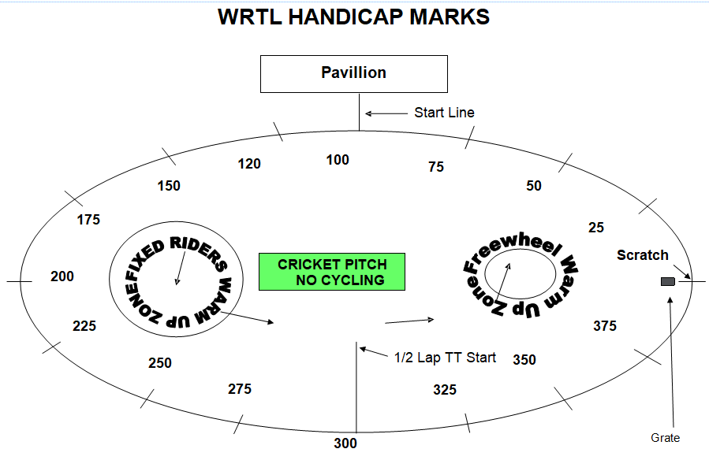

PROGRAMME SUBJECT TO CHANGE DEPENDING ON NUMBERS AND ABILITIES
This is the first event in a series and will set the ability groups for the following week so ride as fast as you can! Next week all riders will be in ability groups. It is also a shorter event due to available light.
Under 8 Riders are Born 2013 or Later | Under 10 Riders are Born 2011-2012
Under 12 Riders are Born 2009-2010 | Under 14 Riders are Born 2007-2008
Under 16 Riders are Born 2005-2006 | Junior Riders are Born 2003-2004
FREEWHEEL GROUPS:
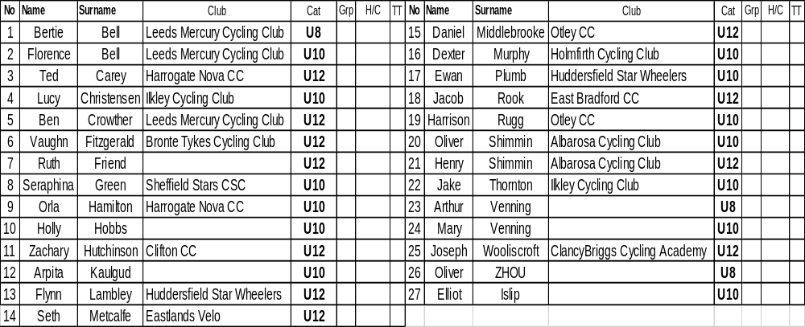

FIXED WHEEL GROUPS:These groups are provisional and will change according to results.

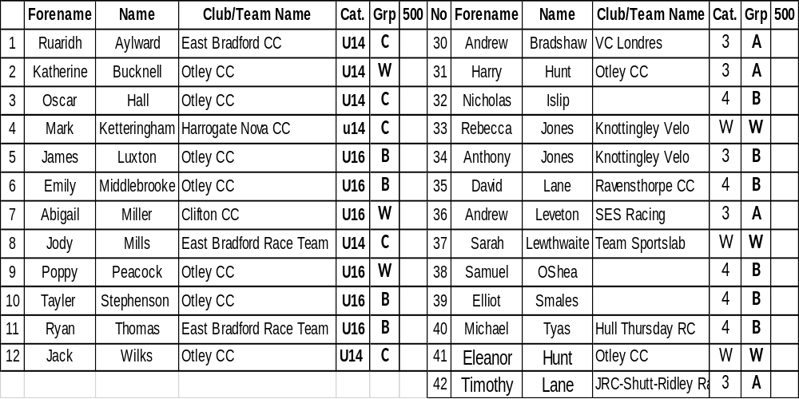
6.45 pm Start Prompt for U8/U10/U12

Race 1 1/2 Lap TT Under 8/10/12 Youth Riders
(Line up at the ½ way line in number order opposite side to the pavilion in number order, lowest first).
You will ride half a lap to cross the finish line after the judges near the pavilion

Race 2: Freewheel Under 8 Boys 1 Lap Sprint race - On start line

Race 3: Freewheel Under 10/12 Girls 1 Lap Sprint race - On start line

Race 4: Freewheel Under 10 Boys 1 Lap Sprint race - On start line

Race 5: Freewheel Under 12 Boys 1 Lap Sprint race - On start line

Race 6: Freewheel Under 8 Boys 1 Lap Scratch races On the start line

Race 7 : Under 10/12 Girls 2 Lap Scratch race - On start line

Race 8: Freewheel Under 10 Boys 2 Lap Scratch race

Race 9: Freewheel U12 Boys 2 Lap Scratch Race

Fixed wheel race to start at 7.30 so U8/10/12 events may move slightly.

Race 10 Fixed Wheel Women and U14/16 Girls Scratch Race – Rolling start 3 - Laps

Race 11 Fixed Wheel 6 Lap Block Handicap Groups A-C This is just an initial grouping -Riders will be put into different groups after the first week

Group | Mark | No | No | No | No | No | No | No
A | Finish Line
B | H/C Mark 200
C | H/C mark 300

Race 12: Under 8/10/12 Boys Handicap 500m Marks to be announced

Race 13: Under 8/10/12 Girls Handicap 500m Marks to be announced

End of events for Under 8’s and Under 10’s

Race 14 Fixed Wheel 1 Lap Sprint heats (Probably 1st to final,) No of riders through and number of heats dependant on number of riders on the night.

Heat 1 Heat 2

1st 2nd 3rd 1st 2nd 3rd

Heat 3 Heat 4

1st 2nd 3rd 1st 2nd 3rd
Heat 5 Heat 6

1st 2nd 3rd 1st 2nd 3rd

Race 15 Women and u14/16 Girls 1 Lap Sprint Heats – Straight final if less than 8
Heat 1 Heat 2

1st 2nd 3rd 1st 2nd 3rd

Race 16: Freewheel Under 12 Boys/Girls Devil – Rolling Start 2 Out each Lap

Race 17: Fixed Wheel 1 Lap Men’s Sprint Final Numbers to be announced.

Race 18: Freewheel Under 12 Boys/Girls 3 Lap Scratch
End of events for the Under 12’s

Fixed Wheel Devil - All Fixed Riders - 2 riders to be eliminated each lap until 4 remain. Points 3,2,1 Rolling Start – For those not in the sprint final although they are welcome to take part.

Race 19: Fixed Wheel 3 Lap Scratch race Groups C

Race 20: Fixed Wheel Women and Girls 3 Lap Scratch

Race 21: Fixed Wheel 3 Lap Scratch Race Groups A & B

Race 22: Fixed Wheel Unknown Distance All Riders ( Depending on Time)

After the first meeting, all riders will be grouped according to ability. The first meeting is just to decide the balance of events between the youth and adult riders and will change in week two so please bear with us. Also next week we introduce the fixedwheel handicap races.

