PROGRAMME SUBJECT TO CHANGE DEPENDING ON NUMBERS AND ABILITIES
Please note the following years of birth which determine a child’s age category for the programme. New riders complete a Time Trial and then compete in the races for their age categories for the first week. The week after they will be in ability groups.
Under 8 Riders are Born 2013 or Later | Under 10 Riders are Born 2011-2012
Under 12 Riders are Born 2009-2010 | Under 14 Riders are Born 2007-2008
Under 16 Riders are Born 2005-2006 | Junior Riders are Born 2003-2004
THESE ARE PROVISIONAL GROUPS AND HANDICAPS
FREEWHEEL GROUPS:
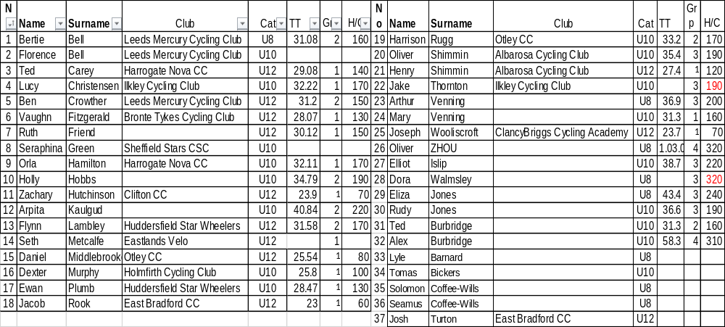
FIXED WHEEL GROUPS:
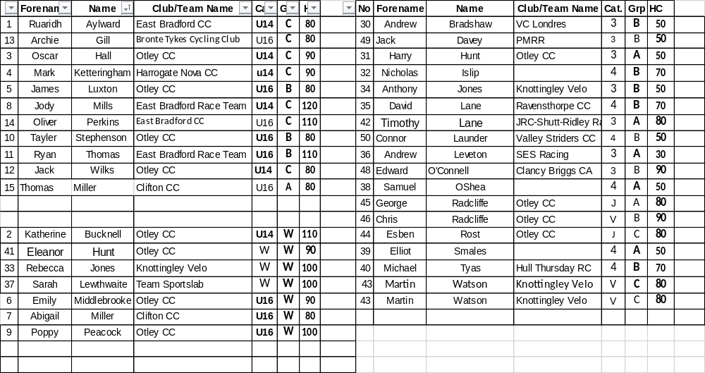

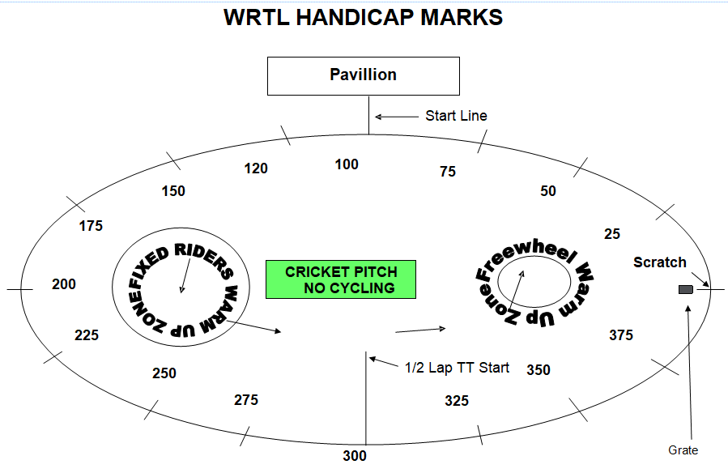

FREEWHEEL RACES– New Riders and Groups 2-4 will have minimum 3 Events, Top Groups will have more.
6.45 pm Start Prompt for Freewheel U8/U10/U12

Race 1 1/2 Lap TT ALL NEW RIDERS WHO HAVEN’T DONE A TT THIS SEASON
½ Lap Time Trial (Line up at the ½ way line in number order opposite side to the pavilion in number order, lowest first.)
You will ride half a lap to cross the finish line after the judges near the pavilion
Freewheel Scratch Races:
Race 2: Group 4 Boys 1 Lap Scratch race Including New Under 8
Race 3 Group 3 Girls 1 Lap Scratch race Including New Under 8 Riders
Race 4: Group 3 Boys 2 Lap Scratch race Including New Under 10 Riders
Race 5: Group 2 Boys 2 Lap Scratch Race Including New Under 12 Riders
Race 6:Group 1 Boys 2 Lap Scratch race
Race 7: Group 1 / 2 Girls 2 Lap Scratch Race Including New Under 10/12 Riders
Race 8 Group 4 Boys 1 Lap Sprint Including New Under 8 Riders
Race 9: Group 3 Girls 1 Lap Sprint Including New Under 8 Riders
Race 10 Group 3 Boys 1 Lap Sprint Including New Under 10 Riders
Race11: Group 2 Boys 1 Lap Sprint Including New Under 12 Riders
Race 12 Group 1 Boys 1 Lap Sprint
Race 13 Group 1/2 Girls 1 Lap Sprint Including New Under 10/12 Riders
Fixed Wheel Riders first event will be as near to 7.30pm as possible so some of the freewheel races may be delayed or brought forward.
Race 14: Fixed Wheel Women and Girls Scratch Race – Rolling start 3 - Laps
Race 15: Fixed Wheel 6 Lap Block Handicap Groups A-C Only – New Riders will be advised.

Group | Mark | No | No | No | No | No
A | Finish Line
B | H/C Mark 190
C | H/C mark 310
MIXED Freewheel Handicap Races – All 500m. Marks as per programme and new riders will have their marks announced – please listen carefully.
Handicap Marks are shown on the pegs around the arena on the line at 10m intervals approximately. Scratch (0) starts at the grate just past the Lewis Barry bench looking towards the playground, 100 is by the finish line – follow the marks round to the right place. Riders on marks 0-90 will ride through the finish line and then a full lap, riders at marks 100+ will race to the finish line
Race 16: Freewheel Group 3 & 4 Boys and Girls 500m Handicap Incl New Under 8/10s
This is the Last event for Group 3 and 4 Boys
Race 17: Freewheel Group 1 & 2 Boys 500m Handicap Incl New Under 12s
Race 18: Freewheel Group 1 & 2 & 3 Girls 500m Handicap Including All New Riders

This is the last event for Group 2 Boys and Girls

Race 19: Women and Girls 1 Lap Sprint Heats or Straight Final if not enough.

Heat 1 1st 2nd 3rd Heat 2 1st 2nd 3rd

Race 20 : Fixed Wheel 1 Lap Sprint heats (Probably 1st to final,) No of riders through and . number of heats dependant on number of riders on the night.
Heat 1 Heat 2

1st 2nd 3rd 1st 2nd 3rd

Heat 3 Heat 4

1st 2nd 3rd 1st 2nd ^{rd}

Devil Take The Hindmost - 2 riders to be eliminated each lap until 4 remain. Remaining riders sprint for the final lap Points 3,2,1 Rolling Start
Race 21: Freewheel Groups 1 Boys and Girls Devil
This is the last event for Group 1
Race 22: Fixed Wheel Women and Girls Sprint Final if two heats, if not a 500m Handicap

Race 23: Fixed Wheel 1 Lap Sprint Final Numbers to be announced.

Race 24: If enough Riders - To be decided on night - Fixed Wheel Devil Women and Girls – 1 out each lap (See above).

Race 25: Fixed Wheel Devil – Men and Boys Fixed Wheel – 2 out each lap * May run all fixed wheelers together if don’t have enough women and girls.

Race 26: Fixed Wheel Women and Girls 500m handicap

Ht | No | No | No | No | No | No | No | No | No
1
2
3

Race 27: Fixed Wheel 500m Men’s Handicap Heats Riders to be announced and No’s through.
Ht | No | No | No | No | No | No | No | No | No
1
2

Race 28: Fixed Wheel Women’s 5 Lap Scratch Race

Race 29: Men’s Fixed Wheel Handicap Final Nos to be announced
Final | No | No | No | No | No | No | No | No | No

Race 29: Fixed Wheel Unknown Distance All Riders ( Depending on Time)

End

