WEST RIDING TRACK LEAGUE
2022

Under 8 Riders are Born 2014 or Later | Under 10 Riders are Born 2012-2013
Under 12 Riders are Born 2010-2011 | Under 14 Riders are Born 2008-2009
Under 16 Riders are Born 2006-2007 | Junior Riders are Born 2004-2005  Adults 2004 or earlier
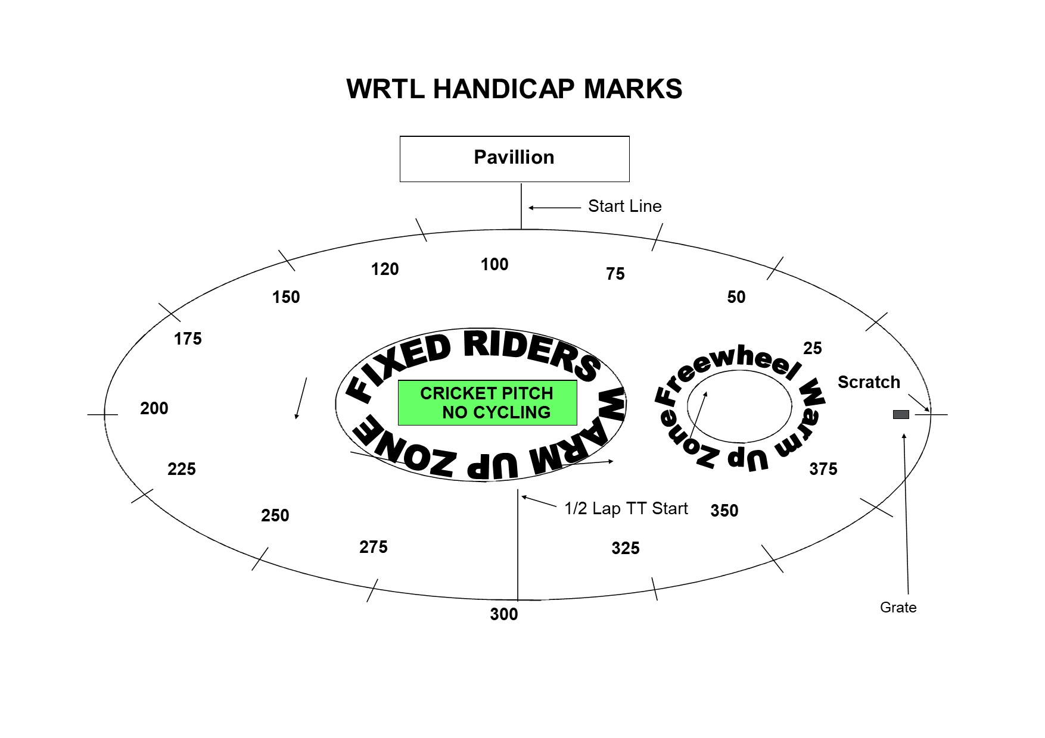

PROGRAMME SUBJECT TO CHANGE DEPENDING ON NUMBERS AND ABILITIES
This is the first event in a series and will set the ability groups for the following week so ride as fast as you can! Next week all riders will be in ability groups. Tonight is also a shorter event due to available light.
WHEN FINISHING A RACE, ALL RIDERS GO PAST THE FINISH LINE AND TURN INTO THE CENTRE OF THE TRACK AFTER THE 120 FLAG

FREEWHEEL GROUPS:
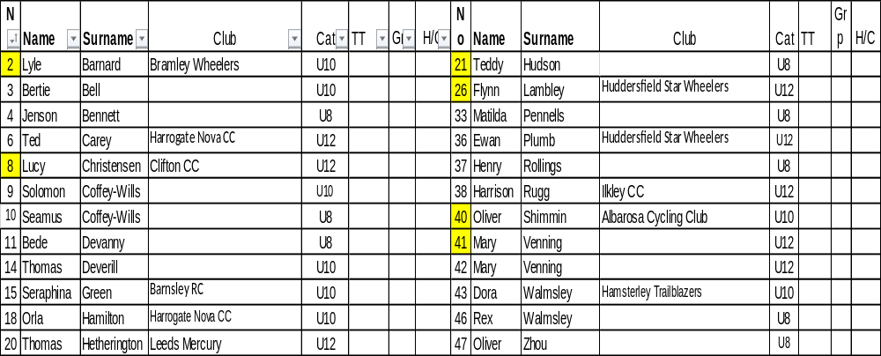

FIXED WHEEL GROUPS: These groups are provisional and will change according to results.

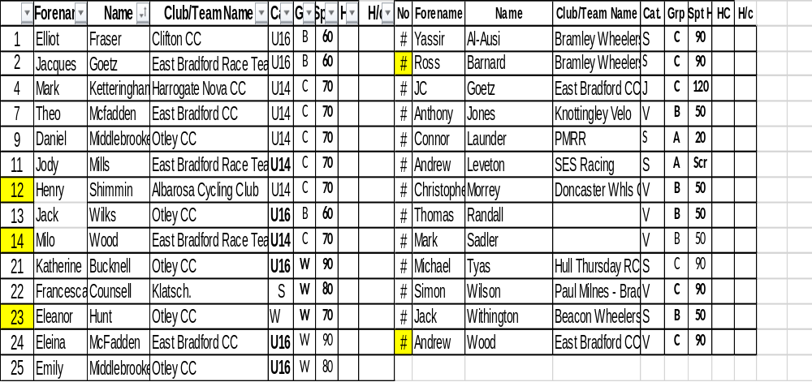

7

Race 1 1/2 Lap TT Under 8/10/12 Youth Riders
(Line up at the ½ way line in number order opposite side to the pavilion in number order, lowest first).
You will ride half a lap to cross the finish line after the judges near the pavilion

Race 2: Freewheel Under 8 1 Lap Sprint race - On start line

Race 3: Freewheel Under 10 1 Lap Sprint race - On start line

Race 4: : Freewheel Under 12 1 Lap Sprint race - On start line

Race 5 Freewheel Under 8 1 Lap Scratch races On the start line

Race 6: Freewheel Under 10 2 Lap Scratch race

Race 7 : Freewheel U12 3 Lap Scratch Race

Fixed wheel race to start at 7.30 so U8/10/12 events may be held earlier than the programme indicates

Race 8: Fixed Wheel Women and U14/16 Girls Scratch Race – Rolling start 3 - Laps

Race 9: Fixed Wheel 6 Lap Block Handicap Groups A-C This is just an initial grouping -Riders
may be put into different groups after the first week

Group | Mark | No | No | No | No | No | No | No
A | Finish Line
B | H/C Mark 200
C | H/C mark 300

Handicap Races – Riders race from their mark to the finish line
Race 10 Under 8/10/12 Boys Handicap 500m Marks to be announced

Race 11 Under 8/10/12 Girls Handicap 500m Marks to be announced
End of events for Under 8’s

Race 12 Fixed Wheel 1 Lap Sprint heats (Probably 1st to final,) No of riders through and number of heats dependant on number of riders on the night.
Heat 1 Heat 2

1st 2nd 3rd 1st 2nd 3rd

Heat 3 Heat 4

1st 2nd 3rd 1st 2nd 3rd

Race 13 Women and U14/16 Girls 1 Lap Sprint Heats – Straight final if less than 8
Heat 1 Heat 2

1st 2nd 3rd 1st 2nd 3rd

Race 14: Freewheel Under 10/12 Boys/Girls 500 Handicap Race
End of events for Under 10’s

Race 15: Fixed Wheel 1 Lap Men’s Sprint Final Numbers to be announced.

Race 16: Freewheel Under 12 Boys/Girls 3 Lap Scratch
End of events for the Under 12’s

Race 17: Fixed Wheel Devil - All Fixed Riders - 2 riders to be eliminated each lap until 4 remain. Points 3,2,1 Rolling Start – For those not in the sprint final although they are welcome to take part.

Race 19: Fixed Wheel Women and Girls 3 Lap Scratch

Race 20: Fixed Wheel Unknown Distance All Riders ( Depending on Time)

After the first meeting, all riders will be grouped according to ability. The first meeting is just to decide the balance of events between the youth and adult riders and will change in week two so please bear with us. Also next week we introduce the fixed wheel handicap races.

