PROGRAMME SUBJECT TO CHANGE DEPENDING ON NUMBERS AND ABILITIES
Please note the following years of birth which determine a child’s age category for the programme. New riders complete a Time Trial and then compete in the races for their age categories for the first week. The week after they will be in ability groups.
THESE ARE PROVISIONAL GROUPS AND HANDICAPS

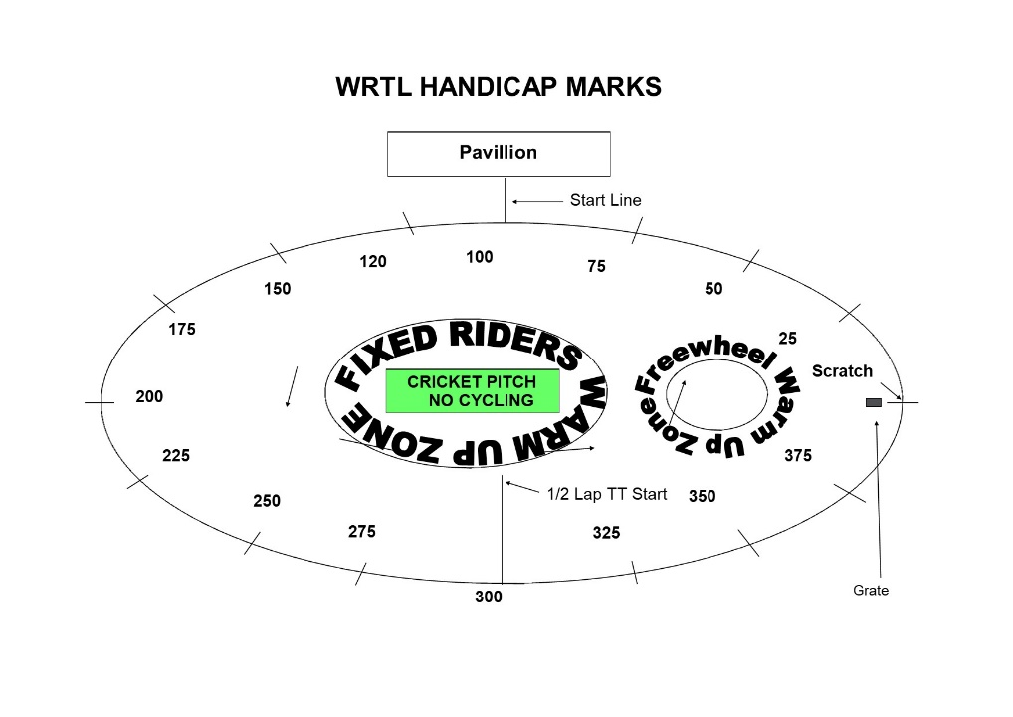

FREEWHEEL GROUPS:
Under 8 Riders are Born 2014 or Later | Under 10 Riders are Born 2012-2013
Under 12 Riders are Born 2010-2011 | Under 14 Riders are Born 2008-2009
Under 16 Riders are Born 2006-2007 | Junior Riders are Born 2004-2005  Adults 2004 or earlier

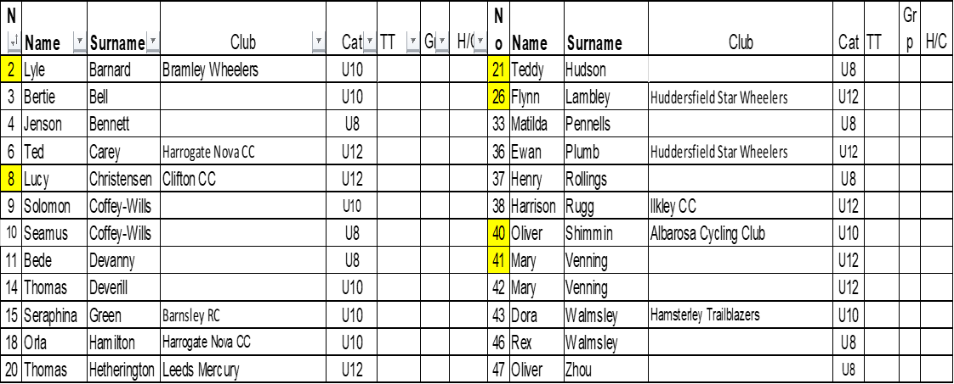
FIXED WHEEL GROUPS:
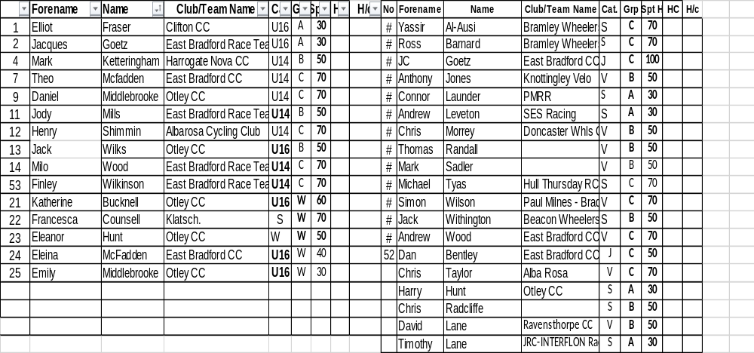

FREEWHEEL RACES– New Riders and Groups 2-4 will have minimum 3 Events, Top Groups will have more.
6.45 pm Start Prompt for Freewheel U8/U10/U12

Race 1 1/2 Lap TT ALL NEW RIDERS WHO HAVEN’T DONE A TT THIS SEASON
½ Lap Time Trial (Line up at the ½ way line in number order opposite side to the pavilion in number order, lowest first.)
You will ride half a lap to cross the finish line after the judges near the pavilion. Remaining races are from the start line unless indicated otherwise
Freewheel Scratch Races:
Race 2: Group 4 - 1 Lap Scratch race Including New Under 8
Race 3 Group 3 - 1 Lap Scratch race Including New Under 10 Riders
Race 4: Group 2- 2 Lap Scratch Race Including New Under 12 Riders
Race 5: Group 1- 3 Lap Scratch Race
Race 6: Group 4- 1 Lap Sprint race Including New Under 8
Race 7: Group 3 - 1 Lap Sprint race Including New Under 10 Riders
Race 8 Group 2 - 1 Lap Sprint Race Including New Under 12 Riders
Race 9: Group 1 - 1 Lap Sprint Race
Fixed Wheel Riders first event will be as near to 7.30pm as possible so some of the freewheel races may be delayed or brought forward.
MIXED Freewheel Handicap Races – All 500m. Marks as per programme and new riders will have their marks announced – please listen carefully.
Handicap Marks are shown on the pegs around the arena on the line at 10m intervals approximately. Scratch (0) starts at the grate just past the Lewis Barry bench looking towards the playground, 100 is by the finish line – follow the marks round to the right place. Riders on marks 0-90 will ride through the finish line and then a full lap, riders at marks 100+ will race to the finish line
Race 10 Freewheel Group 3 & 4 500m Handicap Incl New Under 8/10s
This is the Last event for Group 3 and 4
Race11: Freewheel Group 2 500m Handicap Including All New Riders
Race 12 Fixed Wheel Women and Girls Scratch Race – Rolling start 3 - Laps
Race 13 Fixed Wheel 6 Lap Block Handicap Groups A-C – New Riders will be advised.

Group | Mark | No | No | No | No | No
A | Finish Line
B | H/C Mark 190
C | H/C mark 310

Race 14:Freewheel Group 1 500m Handicap
Race 15: : Fixed Wheel Women and Girls 500m Handicap

Race 16: Fixed Wheel 1 Lap Sprint heats (Probably 1st to final,) No of riders through and . number of heats dependant on number of riders on the night.
Heat 1 Heat 2

1st 2nd 3rd 1st 2nd 3rd

Heat 3 Heat 4

1st 2nd 3rd 1st 2nd ^{rd}
Race 17: Freewheel Group 1&2 2 Lap Race
This is the last event for Group 1 &2 Boys and Girls

Race 18: Women and Girls 1 Lap Sprint Final

Race 19 Fixed Wheel 1 Lap Sprint Final Numbers to be announced.

Devil Take The Hindmost - 2 riders to be eliminated each lap until 4 remain. Remaining riders sprint for the final lap Points 3,2,1 Rolling Start

Race 20 : Fixed Wheel Devil –– 2 out each Lap
Race 21: Freewheel Group 1&2 - Unknown distance. Rolling start from the Scratch Mark

Race 22: : Fixed Wheel 500m Men’s Handicap Heats Riders to be announced and No’s through.

Ht | No | No | No | No | No | No | No | No | No
1
2
3

Race 23: Fixed Wheel Women and Girls 500m handicap

Race 24: Men’s Fixed Wheel Handicap Final Nos to be announced

Final | No | No | No | No | No | No | No | No | No

Race 25: : Fixed Wheel Unknown Distance All Riders ( Depending on Time)

End

