PROGRAMME SUBJECT TO CHANGE DEPENDING ON NUMBERS AND ABILITIES
Please note the following years of birth which determine a child’s age category for the programme. New riders complete a Time Trial and then compete in the races for their age categories for the first week. The week after they will be in ability groups.
THESE ARE PROVISIONAL GROUPS AND HANDICAPS

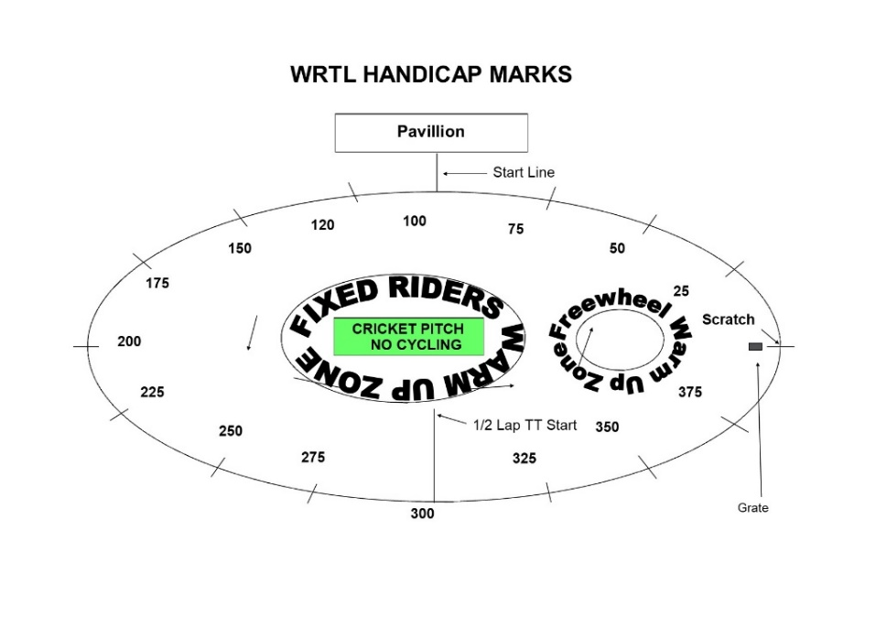

FREEWHEEL GROUPS:
Under 8 Riders are Born 2014 or Later | Under 10 Riders are Born 2012-2013
Under 12 Riders are Born 2010-2011 | Under 14 Riders are Born 2008-2009
Under 16 Riders are Born 2006-2007 | Junior Riders are Born 2004-2005  Adults 2004 or earlier
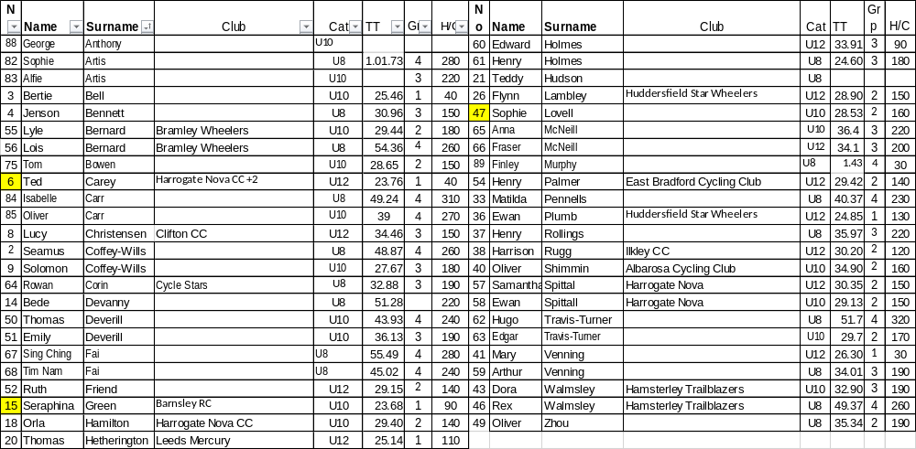
FIXED WHEEL GROUPS:
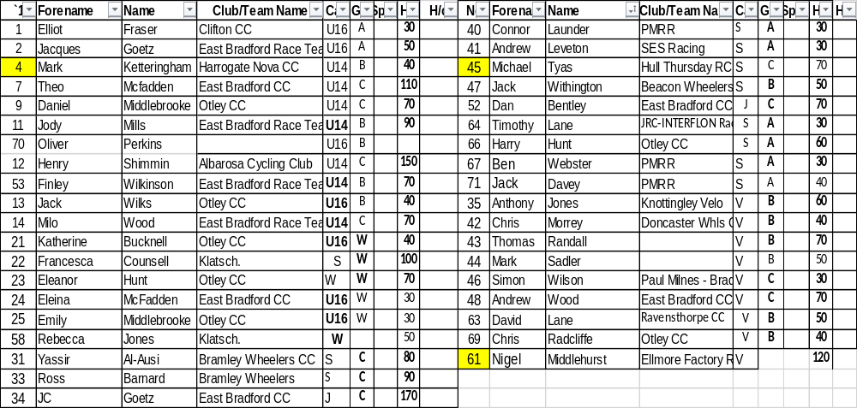
FREEWHEEL RACES– New Riders and Groups 2-4 will have minimum 3 Events, Top Groups will have more.
6.45 pm Start Prompt for Freewheel U8/U10/U12

Race 1 1/2 Lap TT ALL NEW RIDERS WHO HAVEN’T DONE A TT THIS SEASON
½ Lap Time Trial (Line up at the ½ way line in number order opposite side to the pavilion in number order, lowest first.)
You will ride half a lap to cross the finish line after the judges near the pavilion. Remaining races are from the start line unless indicated otherwise
Freewheel Scratch Races:
Race 2: Group 4 - 1 Lap Scratch race Including New Under 8
Race 3 Group 3 - 1 Lap Scratch race Including New Under 10 Riders
Race 4: Group 1 & 2- 2 Lap Scratch Race Including New Under 12 Riders
Race 5: Group 3 & 4- 1 Lap Sprint race Including New Under 8
Race 6: Group 1 & 2 - 1 Lap Sprint Race Including New Under 12 Riders
MIXED Freewheel Handicap Races – All 500m. Marks as per programme and new riders will have their marks announced – please listen carefully.
Handicap Marks are shown on the pegs around the arena on the line at 10m intervals approximately. Scratch (0) starts at the grate just past the Lewis Barry bench looking towards the playground, 100 is by the finish line – follow the marks round to the right place. Riders on marks 0-90 will ride through the finish line and then a full lap, riders at marks 100+ will race to the finish line
Race 7 Freewheel Group 3 & 4 500m Handicap Incl New Under 8s

This is the Last event for Group 4

Race:8 Freewheel Group 1 & 2 500m Handicap Including All New Riders
Fixed Wheel Riders first event will be as near to 7.30pm as possible so some of the freewheel races may be delayed or brought forward.
Race 9: Fixed Wheel Women and Girls Scratch Race – Rolling start 3 - Laps
Race 10: Fixed Wheel 6 Lap Block Handicap Groups A-C – New Riders will be advised.

Group | Mark | No | No | No | No | No
A | Finish Line
B | H/C Mark 210
C | H/C mark 340

Regional Sprint Championships – Please note that if there is only 1 in the category, medals are not awarded under BC rules.
Race 11: : Women and Girls 1 Lap Sprint Championship ( Medals) (Separate Results for U14/U16 and W)

Race 12: Fixed Wheel 1 Lap Men and Boys Sprint Championships (Top 2 in each Category go through to the Summersgill Cup Race)
U14 Sprint Championship (Medals) U16 Sprint Championship (Medals)

1st 2nd 3rd 1st 2nd 3rd

Junior/Senior Sprint Championship (Medals) Vet Sprint Championship (Medals)

1st 2nd 3rd 1st 2nd ^{rd}

Race 13: : Freewheel Group 1 & 2 – 2 Lap Scratch Race
Race 14: Fixed Wheel Women and Girls 3K(7.5Laps) Endurance Championship
( Medals) (Separate Results for U14/U16 and W )

Race 15: Summersgill Sprint Cup Race (Top 2 in each Category from Event 12 go through to the Summersgill Cup Race)

Race 16 : : Freewheel Group 1 – 2 Lap Scratch Race

Race 17: Men and Boys 8K Endurance Race 12 1/2 Laps (ELLIS BROWN CUP) Medals for top 3 in the U14 cat, the top 3 in the U16 cat and the combined S/J/ and the Vets – 4 sets.

Race 18 : Freewheel Group 1&2 (and 3 if they wish) Unknown distance. Rolling start from the Scratch Mark
This is the last event for Group 1 &2 Boys and Girls

Race 19: : Fixed Wheel 500m Men’s Handicap Heats Riders to be announced and No’s through.

Ht | No | No | No | No | No | No | No | No | No
1
2
3

Race 20: Fixed Wheel Women and Girls 500m handicap

Race 21: Men’s Fixed Wheel Handicap Final Nos to be announced

Final | No | No | No | No | No | No | No | No | No

Depending on time and light:

Devil Take The Hindmost – minimum 2 riders to be eliminated each lap (commissaires decision on the night) until 4 remain and any off the back of the bunch . Remaining riders sprint for the final lap Points 3,2,1 Rolling Start

Race 22: Fixed Wheel Devil –– 2 out each Lap

Prize Presentation

End

