PROGRAMME SUBJECT TO CHANGE DEPENDING ON N0UMBERS AND A BILITIES
Please note the following years of birth which determine a child’s age category for the programme. New riders complete a Time Trial and then compete in the races for their age categories for the first week. The week after they will be in ability groups.
THESE ARE PROVISIONAL GROUPS AND HANDICAPS

Under 8 Riders are Born 2015 or Later | Under 16 Riders are Born 2007-2008
Under 10 Riders are Born 2013-2014 | Junior Riders are Born 2005-2006
Under 12 Riders are Born 2011-2012 | Senior Riders are Born 1983-2004
Under 14 Riders are Born 2009-2010 | Vets 1982 or earlier
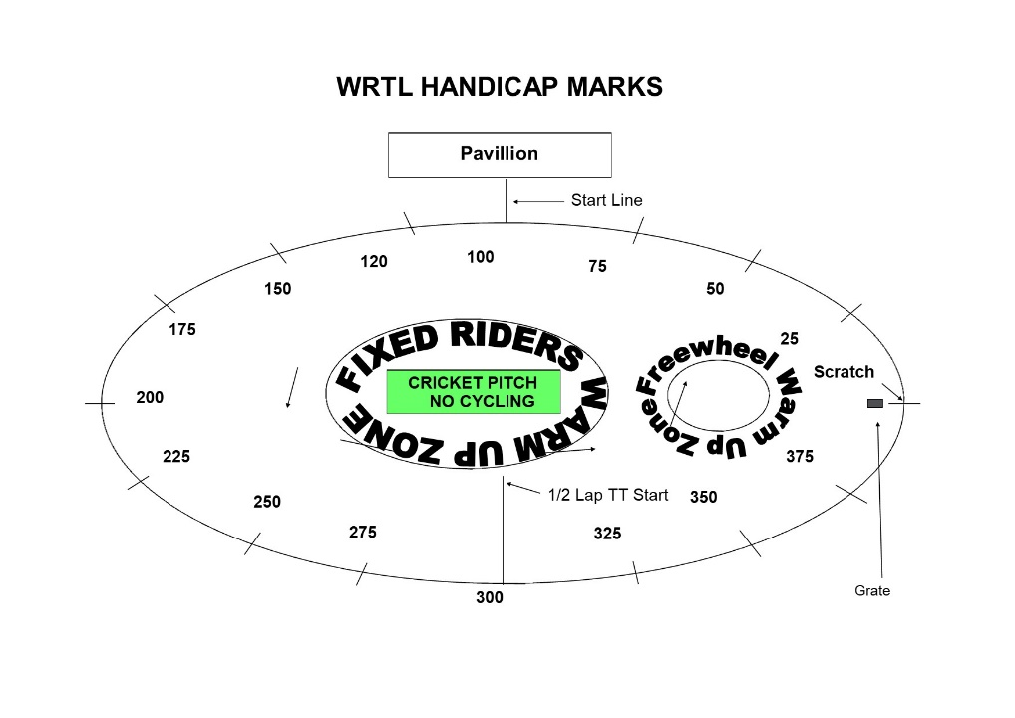

FREEWHEEL GROUPS:

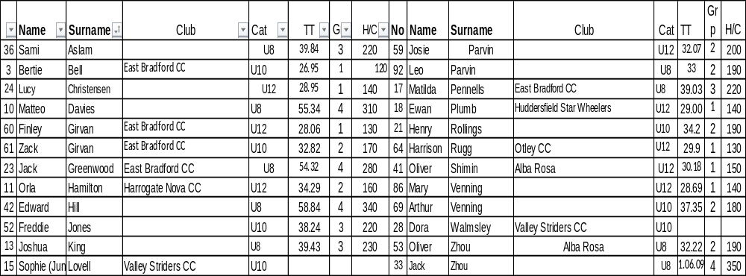

FIXED WHEEL GROUPS:
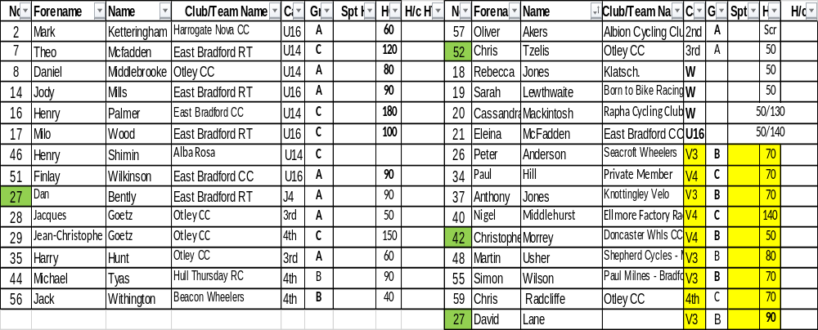

FREEWHEEL RACES– New Riders and Groups 2-4 will have minimum 3 Events, Top Groups will have more.
6.45 pm Start Prompt for Freewheel U8/U10/U12

Race 1 1/2 Lap TT ALL NEW RIDERS WHO HAVEN’T DONE A TT THIS SEASON
½ Lap Time Trial (Line up at the ½ way line in number order opposite side to the pavilion in number order, lowest first.)
You will ride half a lap to cross the finish line after the judges near the pavilion. Remaining races are from the start line unless indicated otherwise.

** Need full results as Group 4 Riders will be awarded separate Group Points

Freewheel Scratch Races:
Race 2: **Group 3 & 4 - 1 Lap Scratch race Including New Under 8/10 Riders
Race 3: Group 2- 2 Lap Scratch Race Including New Under 12 Riders
Race 4: Group 1- 3 Lap Scratch Race
Race 5: Group **3 & 4 - 1 Lap Sprint race Including New Under 8/10 Riders
Race 6 Group 2 - 1 Lap Sprint Race Including New Under 12 Riders
Race 7: Group 1 - 1 Lap Sprint Race

MIXED Freewheel Handicap Races – All 500m. Marks as per programme and new riders will have their marks announced – please listen carefully.
Handicap Marks are shown on the pegs around the arena on the line at 10m intervals approximately. Scratch (0) starts at the grate just past the Lewis Barry bench looking towards the playground, 100 is by the finish line – follow the marks round to the right place. Riders on marks 0-90 will ride through the finish line and then a full lap, riders at marks 100+ will race to the finish line
Race 8 Freewheel **Group 3 & 4 500m Handicap Incl New Under 8/10s
This is the Last event for Group 3 and 4
Race 9: Freewheel ** Group 2 500m Handicap Including All New U12s Rider
Race 10: Freewheel ** Group 1 500m Handicap
Fixed Wheel Riders first event will be as near to 7.30pm as possible so some of the freewheel races may be delayed or brought forward.
Race 11 Fixed Wheel 5 Lap Block Handicap Groups A-C – New Riders will be advised.
When more Women Riders, we will run more separate events

Group | Mark | No | No | No | No | No
A | Finish Line
B | H/C Mark 190
C | H/C mark 310
W | H/C Mark 350

Race 12: Freewheel Group 2 - 2 Lap Race
This is the last event for Group 2 Boys and Girls

Race 13: Fixed Wheel 1 Lap Sprint heats. No of riders through and number of heats dependant on riders on the night.
Heat 1 Heat 2

1st 2nd 3rd 1st 2nd 3rd

Heat 3 If Req. Heat 4 Vets or Final if less than 8

1st 2nd 3rd 1st 2nd ^{rd}

Heat 5 Vets if Req.

1st 2nd ^{rd}
Race 14: Fixed Wheel Women and Girls Sprint Final

Race 15: Fixed Wheel 1 Lap Mens Sprint Final Numbers to be announced.

Race 16: Fixed Wheel Vets Final if Req.

Race 17: Freewheel Group 1- 500m Handicap Race

All Riders Devil Take The Hindmost - 2 riders to be eliminated each lap until 4 remain. Remaining riders sprint for the final lap Points 3,2,1 Rolling Start
***Experiment***
Race 18 : Fixed Wheel Devil –– Group C and Women -1 or 2 out each Lap and any off the back of the bunch

Race 19: Group A and B Devil- 2 out each Lap and any off the back of the bunch

Race 20: Freewheel Group 1 - 2 Lap Race Rolling start

Fixed Wheel 500m Handicap Races
Race 21:

Race | No | No | No | No | No | No | No | No
U14/16
Women and Girls

Race 22:

Race | HT | No | No | No | No | No | No | No | No | No | No
Jun/Sen Men
Race 23:

Race | No | No | No | No | No | No | No | No | No | No
Vet

Race 24: Fixed Wheel Unknown Distance All Riders ( Depending on Time)

End

