PROGRAMME SUBJECT TO CHANGE DEPENDING ON N0UMBERS AND A BILITIES
Please note the following years of birth which determine a child’s age category for the programme. New riders complete a Time Trial and then compete in the races for their age categories for the first week. The week after they will be in ability groups.
THESE ARE PROVISIONAL GROUPS AND HANDICAPS

Under 8 Riders are Born 2015 or Later | Under 16 Riders are Born 2007-2008
Under 10 Riders are Born 2013-2014 | Junior Riders are Born 2005-2006
Under 12 Riders are Born 2011-2012 | Senior Riders are Born 1983-2004
Under 14 Riders are Born 2009-2010 | Vets 1982 or earlier
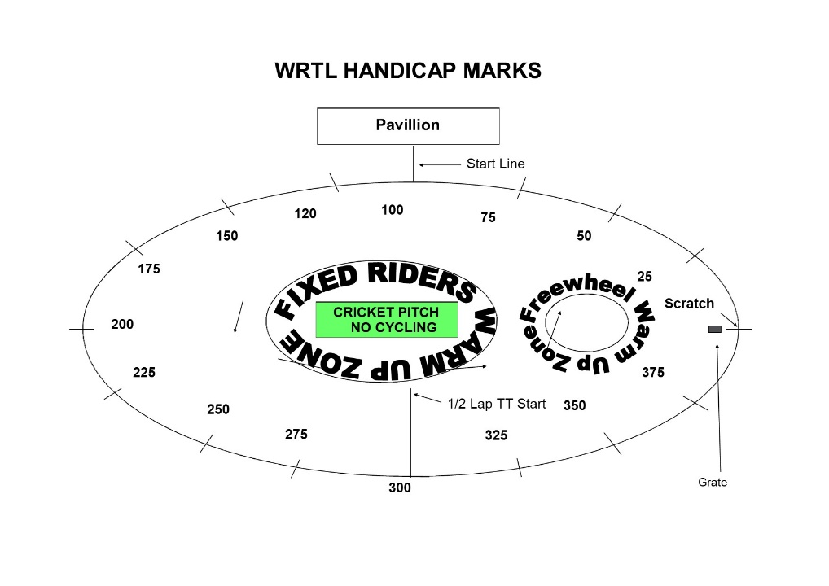

FREEWHEEL GROUPS:

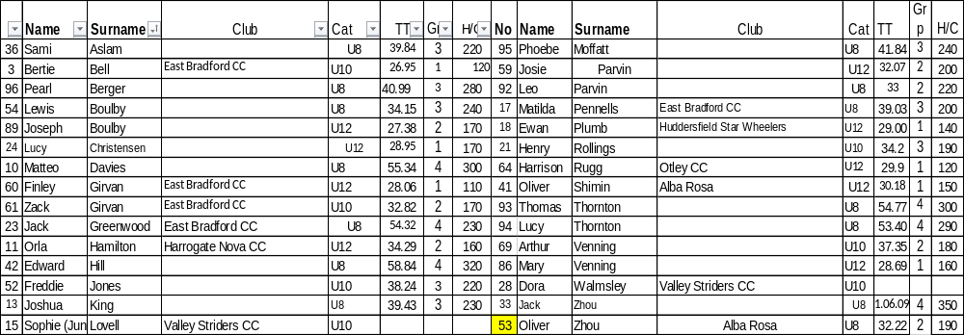
FIXED WHEEL GROUPS:

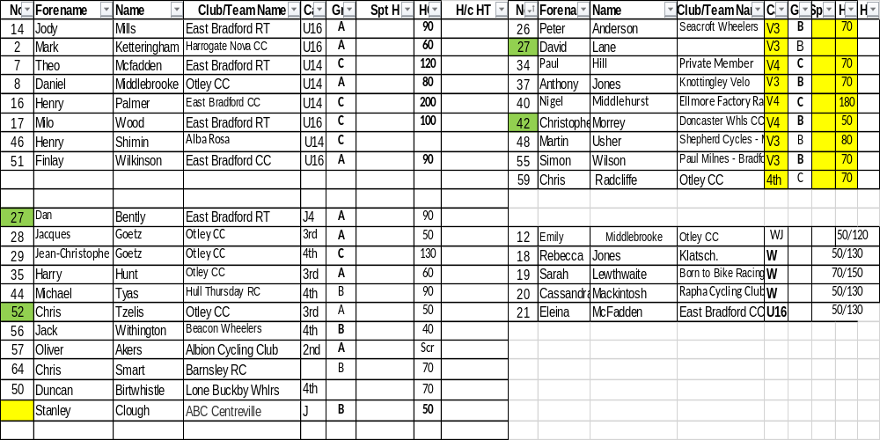
FREEWHEEL RACES– New Riders and Groups 2-4 will have minimum 3 Events, Top Groups will have more.
6.45 pm Start Prompt for Freewheel U8/U10/U12

Race 1 1/2 Lap TT ALL NEW RIDERS WHO HAVEN’T DONE A TT THIS SEASON
½ Lap Time Trial (Line up at the ½ way line in number order opposite side to the pavilion in number order, lowest first.)
You will ride half a lap to cross the finish line after the judges near the pavilion. Remaining races are from the start line unless indicated otherwise.
Freewheel Races- Girls and Boys will receive separate medals in the Championship
Race 2: Under 8 Boys - 1 Lap Sprint Championship including New Under 8
Race 3 Under 8 Girls - 1 Lap Sprint Championship Including New Under 8
Race 4: Under 10 Boys-1 Lap Sprint Championship Including New Under 10 Boys
Race 5 Under 10 Girls- 1 Lap Sprint Championship Including New Under 10 Girls
Race6: Under 12 Boys- 1 Lap Sprint Championship Including New Under 12 Boys
Race 7: Under 12 Girls- 1 Lap Sprint Championship Including New Under 12 Girls
Race 8: Under 8 Boys - 1 Lap Scratch Championship Including New Under 8
Race 9 Under8 Girls- 1 Lap Scratch Championship Including New Under 8
Race 10: Under 10 Boys- 2 Lap Scratch Championship Including New Under 10 Boys
Race 11: Under 10 Girls- 2 Lap Scratch Championship Including New Under 10 Girls
Race 12 Under 12 Boys- 3 Lap Scratch Championship Including New Under 12 Boys
Race 13 Under 12 Girls- 3 Lap Scratch Championship Including New Under 12 Girls
MIXED Freewheel Handicap Races – All 500m. Marks as per programme and new riders will have their marks announced – please listen carefully.
Handicap Marks are shown on the pegs around the arena on the line at 10m intervals approximately. Scratch (0) starts at the grate just past the Lewis Barry bench looking towards the playground, 100 is by the finish line – follow the marks round to the right place. Riders on marks 0-90 will ride through the finish line and then a full lap, riders at marks 100+ will race to the finish line
Race 14 Freewheel Group 3 & 4 500m Handicap Incl New Under 8/10s
This is the Last event for Group 3 and 4
Fixed Wheel Riders first event will be as near to 7.45pm as possible so some of the freewheel races may be delayed or brought forward. Tonight might be delayed due to Under 12 Champs
Podiums will take place during the Block Handicap for U8/10s and during the fixed devil for Under 12s
Race 15 Fixed Wheel 5 Lap Block Handicap Groups A-C – New Riders will be advised.
When more Women Riders, we will run more separate events

Group | Mark | No | No | No | No | No
A | Finish Line
B | H/C Mark 190
C | H/C mark 310
W | H/C Mark 350

Race 16: Freewheel Group 1& 2 - 500m Handicap Incl New U12s
This is the last event for Group 2 Boys and Girls

Race 17: Fixed Wheel 1 Lap Sprint heats. No of riders through and number of heats dependant on riders on the night.
Heat 1 Heat 2

1st 2nd 3rd 1st 2nd 3rd

Heat 3 If Req. Heat 4 Vets or Final if less than 8

1st 2nd 3rd 1st 2nd ^{rd}

Heat 5 Vets if Req.

1st 2nd ^{rd}
Race 18: Fixed Wheel Women and Girls Sprint Final

Race 19: Fixed Wheel 1 Lap Mens Sprint Final Numbers to be announced.
Race 20: Fixed Wheel Vets Final if Req.

Race 21: Freewheel Group 1- 500m Handicap Race

All Riders Devil Take The Hindmost - 2 riders to be eliminated each lap until 4 remain. Remaining riders sprint for the final lap Points 3,2,1 Rolling Start
***Experiment***
Race 22 : Fixed Wheel Devil –– Group C and Women -1 or 2 out each Lap and any off the back of the bunch

Race 23:: Group A and B Devil- 2 out each Lap and any off the back of the bunch

Race 24: Freewheel Group 1 - 2 Lap Race Rolling start
Fixed Wheel 500m Handicap Races
Race 25:
Race | No | No | No | No | No | No | No | No
U14/16
Women and Girls
Race 26:

Race | HT | No | No | No | No | No | No | No | No | No | No
Jun/Sen Men
Race 27:

Race | No | No | No | No | No | No | No | No | No | No
Vet

Race 28: Fixed Wheel Unknown Distance All Riders ( Depending on Time)

