WEST RIDING TRACK LEAGUE 2024

PROGRAMME SUBJECT TO CHANGE DEPENDING ON NUMBERS AND ABILITIES
Please note the following years of birth which determine a child’s age category for the programme. New riders complete a Time Trial and then compete in the races for their age categories for the first week. The week after they will be in ability groups.
THESE ARE PROVISIONAL GROUPS AND HANDICAPS
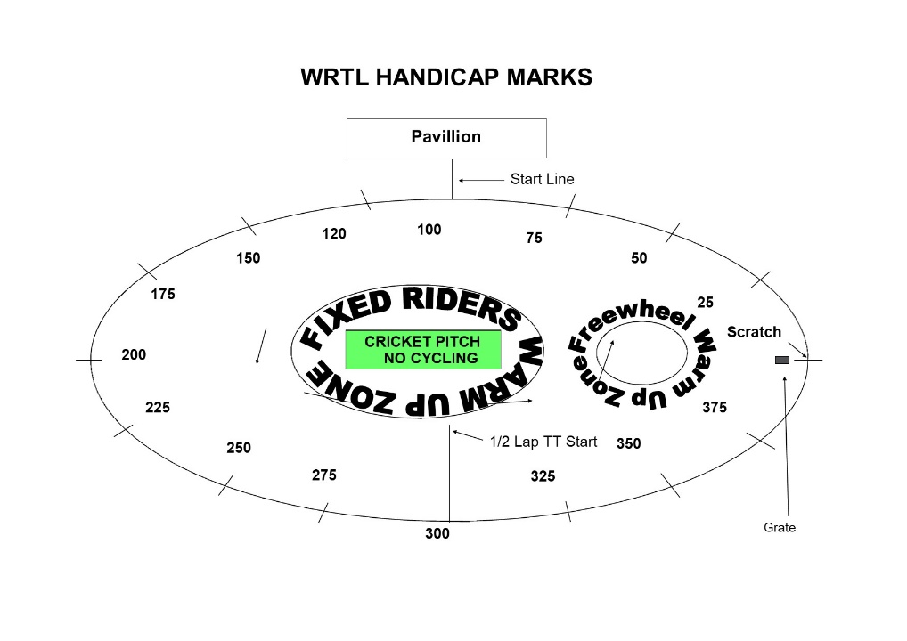
Under 8 Riders are Born 2016 or Later | Under 16 Riders are Born 2008-2009
Under 10 Riders are Born 2014-2015 | Junior Riders are Born 2006-2007
Under 12 Riders are Born 2012-2013 | Senior Riders are Born 1984-2005
Under 14 Riders are Born 2010-2011 | Vets 1983 or earlier

FREEWHEEL GROUPS:
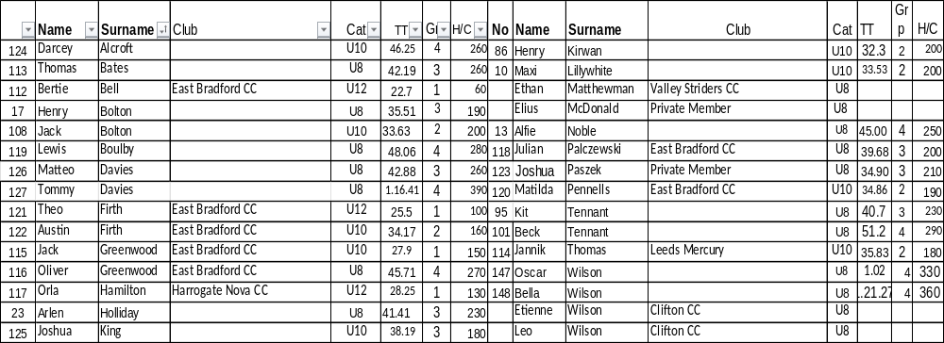

FIXED WHEEL GROUPS:
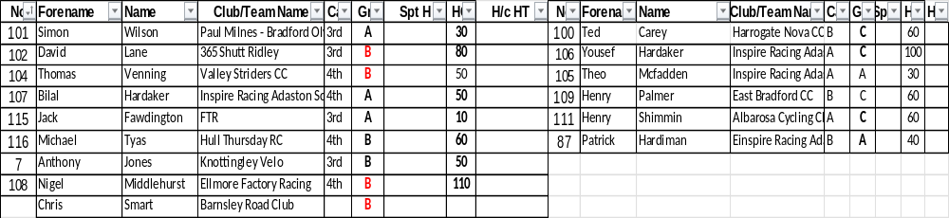

FREEWHEEL RACES– New Riders and Groups 3-4 will have minimum 3 Events, Top Groups will have more.
6.45 pm Start Prompt for Freewheel U8/U10/U12

Race 1 1/2 Lap TT ALL NEW RIDERS WHO HAVEN’T DONE A TT THIS SEASON
½ Lap Time Trial (Line up at the ½ way line in number order opposite side to the pavilion in number order, lowest first.)
You will ride half a lap to cross the finish line after the judges near the pavilion. Remaining races are from the start line unless indicated otherwise.

Freewheel Scratch Races:
Race 2: Group 4 - 1 Lap Scratch race Including New Under 8 Riders
Race 3:Group 3 -1 Lap Scratch Race Including New Under 10 Riders
Race 4: Group 2- 2 Lap Scratch Race Including New Under 12 Riders
Race 5: Group 1- 3 Lap Scratch Race
Race 6: Group 4 - 1 Lap Sprint race Including New Under 8 Riders
Race 7: Group 3 - 1 Lap Sprint race Including New Under 10 Riders
Race 8 Group 2 - 1 Lap Sprint Race Including New Under 12 Riders
Race 9: Group 1 - 1 Lap Sprint Race
MIXED Freewheel Handicap Races – All 500m. Marks as per programme and new riders will have their marks announced – please listen carefully.
Handicap Marks are shown on the pegs around the arena on the line at 10m intervals approximately. Scratch (0) starts at the grate just past the Lewis Barry bench looking towards the playground, 100 is by the finish line – follow the marks round to the right place. Riders on marks 0-90 will ride through the finish line and then a full lap, riders at marks 100+ will race to the finish line
Race 10 Freewheel **Group 3 & 4 500m Handicap Incl New Under 8/10s
This is the Last event for Group 3 and 4
Race 11: Freewheel ** Group 1 & 2 500m Handicap Including All New U12s Rider
Fixed Wheel Riders first event will be as near to 7.30pm as possible so some of the freewheel races may be delayed or brought forward.
Race 12 Fixed Wheel 5 Lap Block Handicap– New Riders will be advised.
When more Women Riders, we will run more separate events

Group | Mark | No | No | No | No | No
A | H/C Mark 120
B | H/C Mark 170
C | H/C mark 310
W | H/C Mark 350

Race 13: Freewheel Group 2 - 2 Lap Race

Race 14: Fixed Wheel 1 Lap Sprint heats. No of riders through and number of heats dependant on riders on the night.

Heat 1 U14/16/Jun/Sen Heat 2 U14/16/Jun/Sen

1st 2nd 3rd 1st 2nd 3rd

Heat 3 Vets or V Final if less than 8 Vets Heat 4 Vets if req.

1st 2nd 3rd 1st 2nd ^{rd}

Race 15: Freewheel Group 1 & 2
Devil Take the Hindmost 1 or 2 out each lap 2 riders to be eliminated each lap until 3 remain. Remaining riders sprint for the final lap Points 3,2,1 Rolling Start

Race 16: Fixed Wheel 1 Lap Mens Sprint Final Numbers to be announced.

Race 17: Fixed Wheel Vets Final if Req.

Race 18: – Longest Lap – slow roll to the line, track stand until whistle blows, sprint 1 lap to finish

Race 19 : Fixed Wheel Devil ––1or 2 out each Lap and any off the back of the bunch. Comms will decide

Race 20: Freewheel Group 1 - 2 Lap Race Rolling start
Fixed Wheel 500m Handicap Races
Race 21:

Race | No | No | No | No | No | No | No | No
U14/16/Jun/Sen

Race 22:

Race | No | No | No | No | No | No | No | No | No | No
Vet

Race 23: Fixed Wheel Unknown Distance All Riders ( Depending on Time)

End

