WEST RIDING TRACK LEAGUE
2024

Under 8 Riders are Born 2016 or Later | Under 16 Riders are Born 2008-2009
Under 10 Riders are Born 2014-2015 | Junior Riders are Born 2006-2007
Under 12 Riders are Born 2012-2013 | Senior Riders are Born 1984-2005
Under 14 Riders are Born 2010-2011 | Vets 1983 or earlier
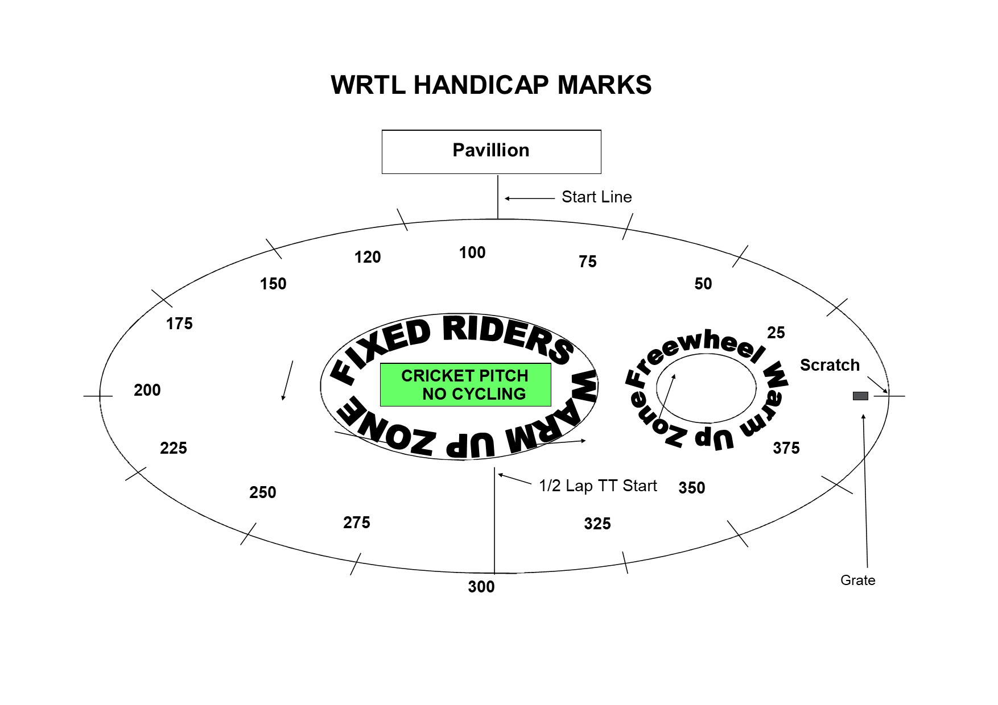

PROGRAMME SUBJECT TO CHANGE DEPENDING ON NUMBERS AND ABILITIES
This is the first event in a series and will set the ability groups for the following week so ride as fast as you can! Next week all riders will be in ability groups. Tonight is also a shorter event due to available light.
WHEN FINISHING A RACE, ALL RIDERS GO PAST THE FINISH LINE AND TURN INTO THE CENTRE OF THE TRACK AFTER THE 120 FLAG

Pre-Registered
FREEWHEEL GROUPS:
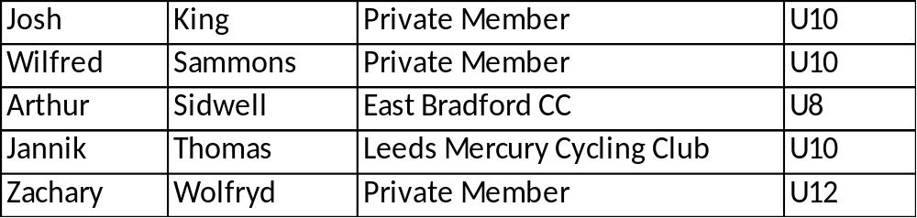

FIXED WHEEL GROUPS: These groups are provisional and will change according to results.

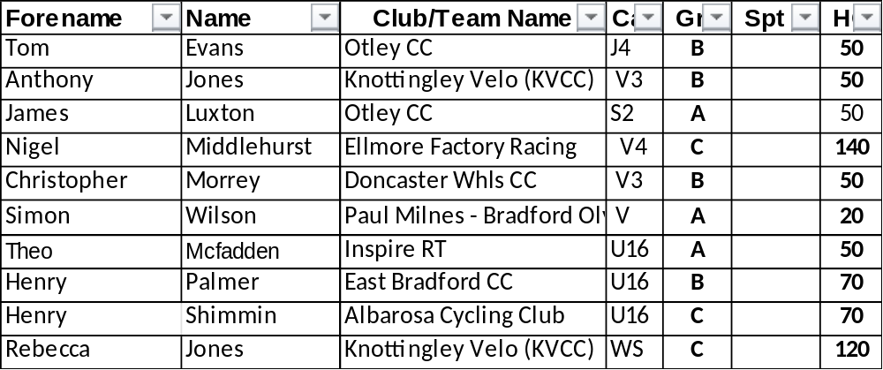
Race 1 1/2 Lap TT Under 8/10/12 Youth Riders
(Line up at the ½ way line in number order opposite side to the pavilion in number order, lowest first).
You will ride half a lap to cross the finish line after the judges near the pavilion

Race 2: Freewheel Under 8 1 Lap Sprint race - On start line

Race 3: Freewheel Under 10 1 Lap Sprint race - On start line

Race 4: : Freewheel Under 12 1 Lap Sprint race - On start line

Race 5 Freewheel Under 8 1 Lap Scratch races On the start line

Race 6: Freewheel Under 10 2 Lap Scratch race

Race 7 : Freewheel U12 3 Lap Scratch Race
Race 8: Handicap Races – Riders race from their mark to the finish line

Race 8 Under 8/10/12 Handicap 500m Marks to be announced

Fixed wheel race to start at 7.30 so U8/10/12 events may be held earlier than the programme indicates. If not enough women, they will race with the other fixed riders.

Race 9: Fixed Wheel Women and U14/16 Girls Scratch Race – Rolling start 3 – Laps

Race 10: Fixed Wheel 6 Lap Block Handicap Groups A-C Groups will be announced on the n
ight

Group | Mark | No | No | No | No | No | No | No
A | Finish Line
B | H/C Mark 200
C | H/C mark 300

End of events for Under 8’s

Race 11 Women and U14/16 Girls 1 Lap Sprint Heats – Straight final if less than 8
Heat 1 Heat 2

1st 2nd 3rd 1st 2nd 3rd

Race 12: Freewheel Under 10/12 Boys/Girls 2 Lap Race

Race 13 :Fixed Wheel 1 Lap Sprint heats (Probably 3 to final,) No of riders through and number of heats dependant on number of riders on the night.
Heat 1 Heat 2

1st 2nd 3rd 1st 2nd 3rd

Heat 3 Heat 4

1st 2nd 3rd 1st 2nd 3rd

Race 14: Freewheel Under 10/12 Boys/Girls 500 Handicap Race

End of events for Under 10’s AND 12s

Race 15: Women and Girls 500m handicap – Marks to be announced

Race 16: Fixed Wheel 1 Lap Men’s Sprint Final Numbers to be announced.

Race 17: Fixed Wheel Devil - All Fixed Riders - 2 riders to be eliminated each lap until 4 remain. Points 3,2,1 Rolling Start – Those in the sprint final can take part.

Race 18: Fixed Wheel Women and Girls 3 Lap Scratch

If not enough women there will be a short break before the last race for recovery.

Race 29: Fixed Wheel Unknown Distance All Riders (Depending on Time)

After the first meeting, all riders will be grouped according to ability. The first meeting is just to decide the balance of events between the youth and adult riders and will change in week two so please bear with us. Also next week we introduce the fixed wheel handicap races.

There will be more events next week as the first week is always shorter to process all the riders and there will be more events in between to allow eiders to recover.

