WEST RIDING TRACK LEAGUE 2025

PROGRAMME SUBJECT TO CHANGE DEPENDING ON NUMBERS AND ABILITIES
Please note the following years of birth which determine a child’s age category for the programme. New riders complete a Time Trial and then compete in the races for their age categories for the first week. The week after they will be in ability groups.

THESE ARE PROVISIONAL GROUPS AND HANDICAPS
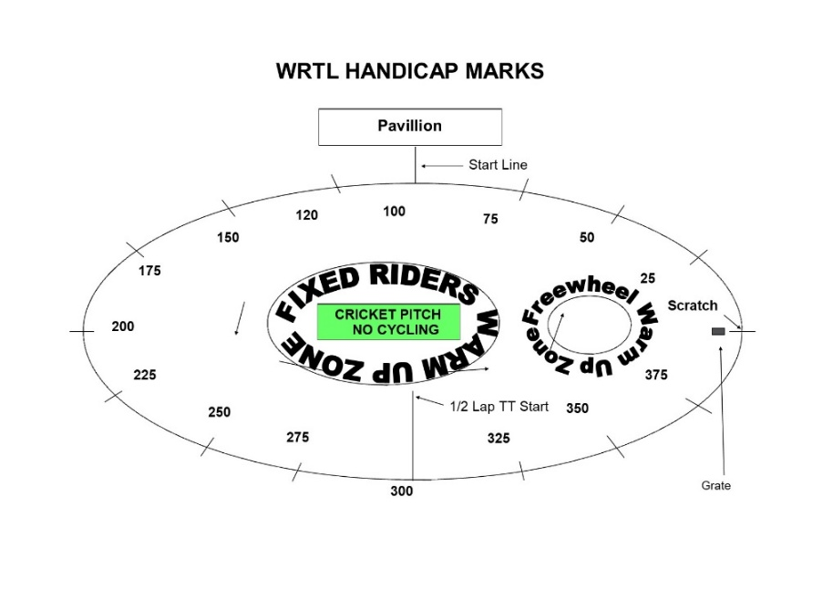
Under 8 Riders are Born 2017 or Later | Under 16 Riders are Born 2009-2010
Under 10 Riders are Born 2015-2016 | Junior Riders are Born 2007-2008
Under 12 Riders are Born 2013-2014 | Senior Riders are Born 1985-2006
Under 14 Riders are Bon 2011-2012 | Vets 1984 or earlier

Explanation:
Freewheel Scratch and Sprint Races
These are straight Races from the start line.
MIXED Freewheel Handicap Races – All 500m. Marks as per programme and new riders will have their marks announced – please listen carefully.
Handicap Marks are shown on the pegs around the arena on the line at 10m intervals approximately. Scratch (0) starts at the grate just before the Lewis Barry bench looking towards the playground, 100 is by the finish line – follow the marks round to the right place. Riders on marks 0-90 will ride through the finish line and then a full lap, riders at marks 100+ will race to the finish line

FREEWHEEL GROUPS FROM PREVIOUS WEEK:
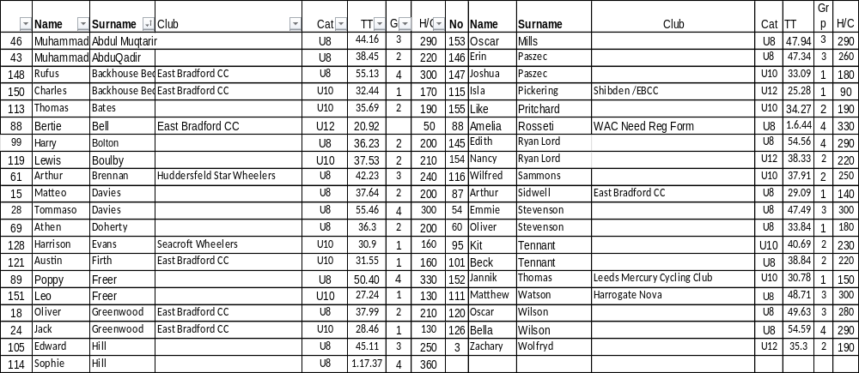
FIXED WHEEL GROUPS:
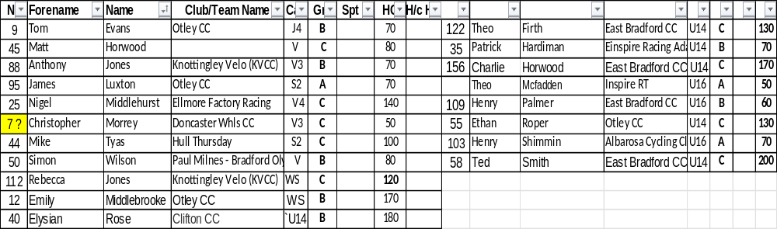
FREEWHEEL RACES– New Riders and Groups 3-4 will have minimum 3 Events, Top Groups will have more.
SIGN ON OPENS AT 6.20 FOR FREEWHEEL RIDERS. 7PM FOR FIXED WHEEL RIDERS
RACES START AT 6.45 pm for Freewheel U8/U10/U12

Race 1 1/2 Lap TT ALL NEW RIDERS WHO HAVEN’T DONE A TT THIS SEASON
½ Lap Time Trial (Line up at the ½ way line in number order opposite side to the pavilion in number order, lowest first.)
You will ride half a lap to cross the finish line after the judges near the pavilion. Remaining races are from the start line unless indicated otherwise.
Freewheel Races:
Race 2: Group 4 – 1 Lap race Including New Under 8 Riders
Race 3:Group 3 - 1 Lap race Including New Under 10 Riders
Race 4: Group 2- 2 Lap Scratch Race Including New Under 12 Riders
Race 5: Group 1- 3 Lap Scratch Race
Race 6: Group 4 – Handicap race Including New Under 8 Riders
Race 7: Group 3 – Handicap Race Including New Under 10 Riders
Race 8 Group 2 - 1 Lap Sprint Race Including New Under 12 Riders
Race 9: Group 1 - 1 Lap Sprint Race
Race 10 Freewheel Group 4 500m Handicap Incl New Under 8/10s
Race 11 Freewheel Group 3 500m Handicap
This is the Last event for Group 3 and 4
Race 12: Freewheel Group 2 - 500m Handicap Including All New U12s Riders
Race 13 Freewheel Group 1 - 500m Handicap
Fixed Wheel Riders first event will be as near to 7.30pm as possible so some of the freewheel races may be delayed or brought forward.
Race 14 Fixed Wheel 5 Lap Block Handicap– New Riders will be advised.

Group | Mark | No | No | No | No | No
A | Finish Line
B | H/C Mark 160
C | H/C mark 290
W | H/C Mark 350
Race 15: Freewheel Group 2 - 2 Lap Race Including New Under 12 Riders

Race 16 : Freewheel Group 1 - 2 Lap Race

Race 17: Fixed Wheel 1 Lap Sprint heats. No of riders through and number of heats dependant on riders on the night.

Heat 1 U14/16/Jun/Sen Heat 2 U14/16/Jun/Sen

1st 2nd 3rd 1st 2nd 3rd

Heat 3 Vets or V Final if less than 8 Vets Women Sprint Final (May be combined
With Youth/Snr)
1st 2nd 3rd 1st 2nd ^{rd}

Race 18 Freewheel Group 2 - 500m Handicap Race Including All New U12s Riders

Race 19: Freewheel Group 1 - 500m Handicap Race

Race 20: Fixed Wheel 1 Lap Men’s Sprint Final Numbers to be announced.

Race 21: Fixed Wheel Vets Final if Req.

Race 22: Freewheel Group 1 – 1 Lap Sprint Race

All Riders Devil Take The Hindmost - 2 riders to be eliminated each lap until 4 remain. Remaining riders sprint for the final lap Points 3,2,1 Rolling Start
***Experiment***
Race 23 : Fixed Wheel Devil ––1 or 2 out each Lap and any off the back of the bunch. Comms will decide

Race 24: Freewheel Group 1 – 3 Lap Race
Fixed Wheel 500m Handicap Races
Race 25:

Race | No | No | No | No | No | No | No | No
U14/16/Jun/Sen/

Race 26:

Race | No | No | No | No | No | No | No | No | No | No
Vet/ Women

Race 27
Fixed Wheel Unknown Distance All Riders ( Depending on Time)

End

