WEST RIDING TRACK LEAGUE 2025

PROGRAMME SUBJECT TO CHANGE DEPENDING ON NUMBERS AND ABILITIES
Please note the following years of birth which determine a child’s age category for the programme. New riders complete a Time Trial and then compete in the races for their age categories for the first week. The week after they will be in ability groups.
Under 8 Riders are Born 2018 or Later | Under 16 Riders are Born 2010-2011
Under 10 Riders are Born 2016-2017 | Junior Riders are Born 2008-2010
Under 12 Riders are Born 2014-2015 | Senior Riders are Born 1986-2007
Under 14 Riders are Born 2012-2013 | Vets 1985 or earlier

THESE ARE PROVISIONAL GROUPS AND HANDICAPS
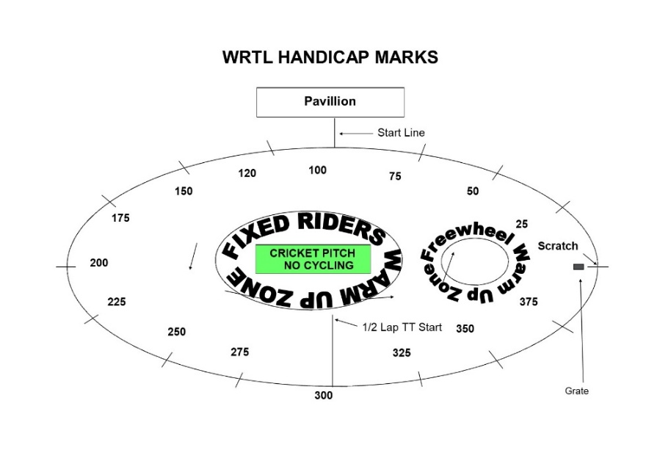

Explanation:
Freewheel Scratch and Sprint Races
These are straight Races from the start line.
MIXED Freewheel Handicap Races – All 500m. Marks as per programme and new riders will have their marks announced – please listen carefully.
Handicap Marks are shown on the pegs around the arena on the line at 10m intervals approximately. Scratch (0) starts at the grate just before the Lewis Barry bench looking towards the playground, 100 is by the finish line – follow the marks round to the right place. Riders on marks 0-90 will ride through the finish line and then a full lap, riders at marks 100+ will race to the finish line

FREEWHEEL GROUPS FROM PREVIOUS WEEK:

FIXED WHEEL GROUPS:
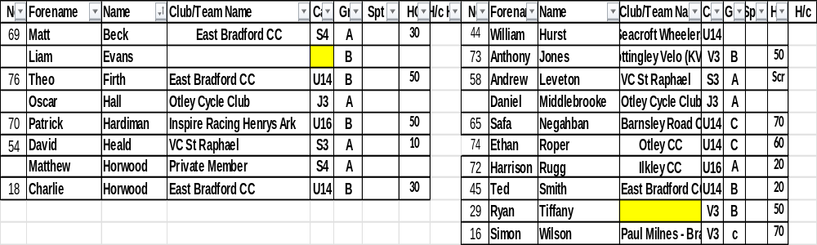

FREEWHEEL RACES– New Riders and Groups 3-4 will have minimum 3 Events, Top Groups will have more.

SIGN ON OPENS AT 6.20 FOR FREEWHEEL RIDERS. 7PM FOR FIXED WHEEL RIDERS

RACES START AT 6.45 pm for Freewheel U8/U10/U12

Race 1 1/2 Lap TT ALL NEW RIDERS WHO HAVEN’T DONE A TT THIS SEASON
½ Lap Time Trial (Line up at the ½ way line in number order opposite side to the pavilion in number order, lowest first.)
You will ride half a lap to cross the finish line after the judges near the pavilion. Remaining races are from the start line unless indicated otherwise.

Freewheel Races:
Race 2: Group 4 – 1 Lap race Including New Under 8 Riders
Race 3: Group 3 - 1 Lap race Including New Under 8 Riders
Race 4: Group 2- 2 Lap Scratch Race Including New Under 10/12 Riders
Race 5: Group 1- 3 Lap Scratch Race
Race 6: Group 4 – Handicap race Including New Under 8 Riders
Race 7: Group 3 – Handicap Race Including New Under 8 Riders
Race 8 Group 2 - Handicap Race Including New Under 10/12 Riders
Race 9: Group 1 - 1 Handicap Race
Race 10 Freewheel **Group 3 & 4 500m Handicap Incl New Under 8/10s

This is the Last event for Group 3 and 4
Race 11: Freewheel ** Group 1 & 2 500m Handicap Including All New U12s Rider
Fixed Wheel Riders first event will be as near to 7.30pm as possible so some of the freewheel races may be delayed or brought forward.
Race 12: Fixed Wheel Women and U14/16 Girls Scratch Race – Rolling start 3 – Laps
Race 13 Fixed Wheel 6 Lap Block Handicap– New Riders will be advised.

Group | Mark | No | No | No | No | No
A | Finish Line
B | H/C Mark 160
C | H/C mark 270
W | H/C Mark 350

Race 14: Freewheel Group 1 & 2 – 1 Lap Sprint Race

Race 15: Fixed Wheel 1 Lap Sprint heats. No of riders through and number of heats dependant on riders on the night.

Heat 1 U14/16/Jun/Sen Heat 2 U14/16/Jun/Sen

1st 2nd 3rd 1st 2nd 3rd

Heat 3 if Req. Women Sprint Final

1st 2nd 3rd 1st 2nd ^{rd}

Race 16: Freewheel Group 1 and 2 - 500m Handicap Race

Race 17: Fixed Wheel 1 Lap Men’s Sprint Final Numbers to be announced.

Race 18: Women and Girls 500m handicap – Marks to be announced

All Riders Devil Take The Hindmost - 2 riders to be eliminated each lap until 4 remain. Remaining riders sprint for the final lap Points 3,2,1 Rolling Start
***Experiment***
Race 19 : All Riders Fixed Wheel Devil ––1 or 2 out each Lap and any off the back of the bunch. Comms will decide

Race 20: Freewheel Groups 1 & 2 - 3 Lap Race
Race 21: Fixed Wheel 500m Handicap Races

Race | No | No | No | No | No | No | No | No
U14/16/Jun/Sen/

Race 22:

Race | No | No | No | No | No | No | No | No | No | No
Vet/ Women

Race 23: Fixed Wheel Unknown Distance All Riders ( Depending on Time)

End

