WEST RIDING TRACK LEAGUE 2026

PROGRAMME SUBJECT TO CHANGE DEPENDING ON NUMBERS AND ABILITIES
Please note the following years of birth which determine a child’s age category for the programme. New riders complete a Time Trial and then compete in the races for their age categories for the first week. The week after they will be in ability groups.
Under 8 Riders are Born 2018 or Later | Under 16 Riders are Born 2010-2011
Under 10 Riders are Born 2016-2017 | Junior Riders are Born 2008-2010
Under 12 Riders are Born 2014-2015 | Senior Riders are Born 1986-2007
Under 14 Riders are Born 2012-2013 | Vets 1985 or earlier

THESE ARE PROVISIONAL GROUPS AND HANDICAPS
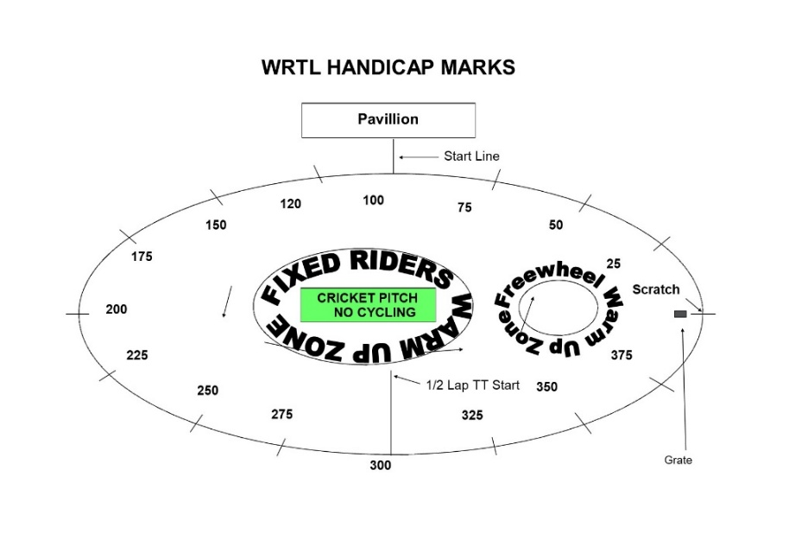

Explanation:
Freewheel Scratch and Sprint Races
These are straight Races from the start line.
MIXED Freewheel Handicap Races – All 500m. Marks as per programme and new riders will have their marks announced – please listen carefully.
Handicap Marks are shown on the pegs around the arena on the line at 10m intervals approximately. Scratch (0) starts at the grate just before the Lewis Barry bench looking towards the playground, 100 is by the finish line – follow the marks round to the right place. Riders on marks 0-90 will ride through the finish line and then a full lap, riders at marks 100+ will race to the finish line

FREEWHEEL GROUPS FROM PREVIOUS WEEK:
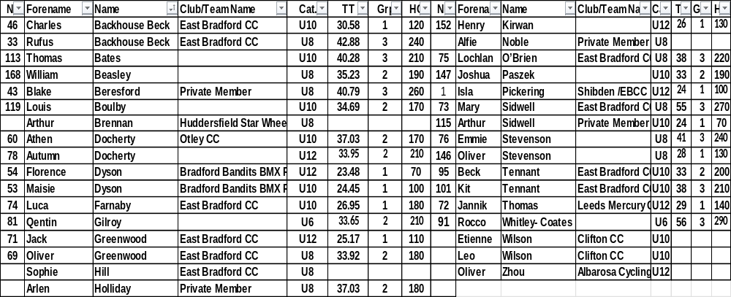
FIXED WHEEL GROUPS:
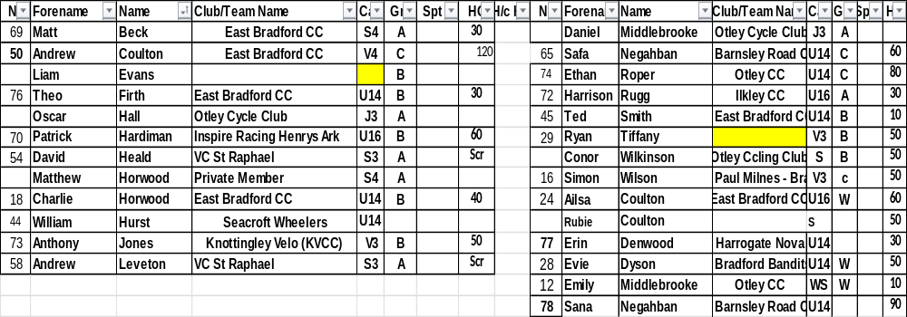
FREEWHEEL RACES– New Riders and Groups 3-4 will have minimum 3 Events, Top Groups will have more.
SIGN ON OPENS AT 6.20 FOR FREEWHEEL RIDERS. 7PM FOR FIXED WHEEL RIDERS
RACES START AT 6.45 pm for Freewheel U8/U10/U12

Race 1 1/2 Lap TT ALL NEW RIDERS WHO HAVEN’T DONE A TT THIS SEASON
½ Lap Time Trial (Line up at the ½ way line in number order opposite side to the pavilion in number order, lowest first.)
You will ride half a lap to cross the finish line after the judges near the pavilion. Remaining races are from the start line unless indicated otherwise.
Freewheel Races:
Race 2: Group 4 – 1 Lap race Including New Under 8 Riders
Race 3:Group 3 - 1 Lap race Including New Under 10 Riders
Race 4: Group 2- 2 Lap Scratch Race Including New Under 12 Riders
Race 5: Group 1- 3 Lap Scratch Race
HANDICAP RACES – ALL FREEWHEEL RIDERS MUST BE WAITING BY THEIR HANDICAP MARKS BUT OFF THE CIRCUIT AT THE BEGINNING OF THE HANDICAP RACES FOR A FASTER FLOW
Race 6: Group 4 – Handicap race Including New Under 8 Riders
Race 7: Group 3 – Handicap Race Including New Under 10 Riders
Race 8 Group 2 - 500m Handicap Race Including New Under 12 Riders
Race 9: Group 1 – 500m Handicap Race Including All New U12s Riders
Fixed Wheel Riders first event will be as near to 7.30pm as possible so some of the freewheel races may be delayed or brought forward.
Race 10 Fixed Wheel 5 Lap Block Handicap– New Riders will be advised.

Group | Mark | No | No | No | No | No
A | Finish Line
B | H/C Mark 160
C | H/C mark 270
W | H/C Mark 350

Race 11 Freewheel Group 4 -500m Handicap Incl New Under 8/10s

Race 12 Freewheel Group 3 - 500m- Handicap
This is the Last event for Group 3 and 4

Race 13:Freewheel Group 2 - 1 Lap Sprint Including All New U12s Riders

Race 14 : Freewheel Group 1 – 1 Lap Sprint

Race 15: Fixed Wheel 1 Lap Sprint heats. No of riders through and number of heats dependant on riders on the night.

Heat 1 U14/16/Jun/Sen Heat 2 U14/16/Jun/Sen

1st 2nd 3rd 1st 2nd 3rd

Heat 3 Women Sprint Final 1st 2nd 3rd

Race 16: Freewheel Group 2 – 3 Lap Race

Race 17: Fixed Wheel 1 Lap Men’s Sprint Final Numbers to be announced.

Race 18 : Fixed Wheel Women’s 500m Handicap Final

All Riders Devil Take The Hindmost – last riders over the line are eliminated plus those way off the back each lap until 4 remain. Remaining riders sprint for the final lap Points 3,2,1 Rolling Start

Race 19 : Freewheel Group 1 & 2 Devil Race – Numbers out each lap down to commissaires.

Race 20 : All Riders Fixed Wheel Devil ––1 or 2 out each Lap and any off the back of the bunch. Comms will decide

Race 21: Freewheel Group 1 & 2 – Longest Lap - Riders ride slowly to the start line but can’t pass it until the whistle blows. They then race 1 Lap
Last Event for Freewheel Riders
Race 22: Fixed Wheel 500m Men’s Handicap Heats

Race | No | No | No | No | No | No | No | No
U14/16/Jun/Sen/
Heat 1
U14/16/Jun/Sen/
Heat 2

Race 23: Women’s 500m Handicap Race

Race 24 Men’s 500m Handicap Final

Race | No | No | No | No | No | No | No | No
U14/16/Jun/Sen/
Heat 1

Fixed Wheel Unknown Distance All Riders ( Depending on Time)

End

